**2-STEP ANN PRACTICAL VALUES**

**900 MHz, 17 (0.05 lambda)**

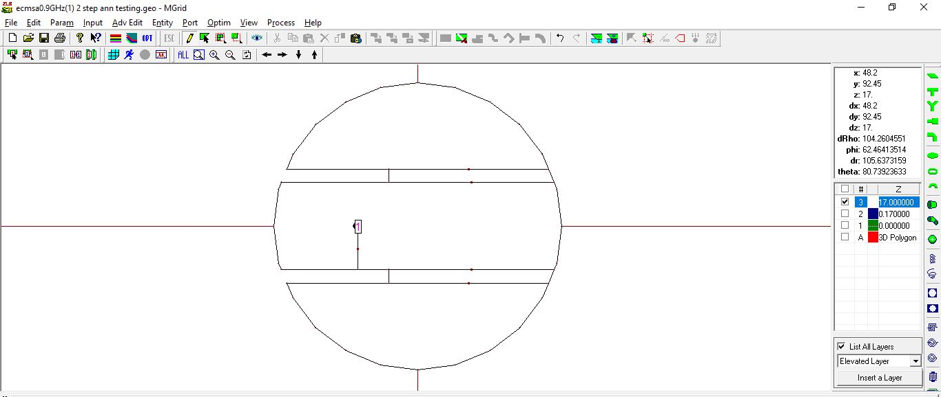

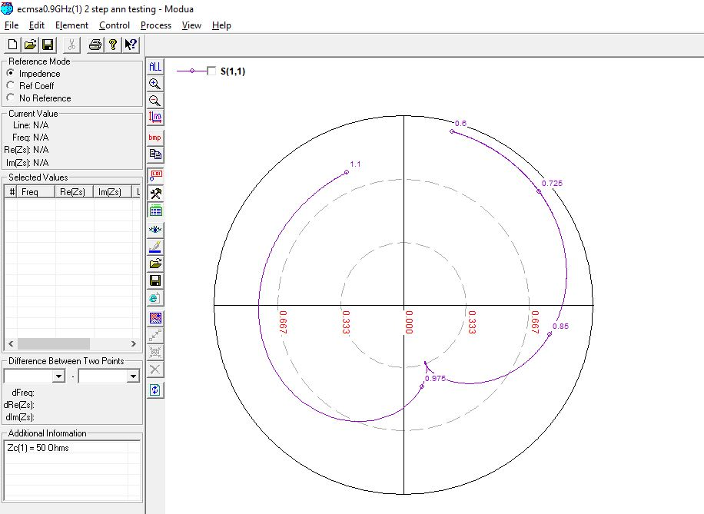

**900 MHz, 17 (0.05 lambda) OPTIMIZED**

Initial values: Feed Position: **-36mm,** Slot Length**: 67mm**

Optimized values: Feed Position**: -29mm,** Slot Length**: 62mm**

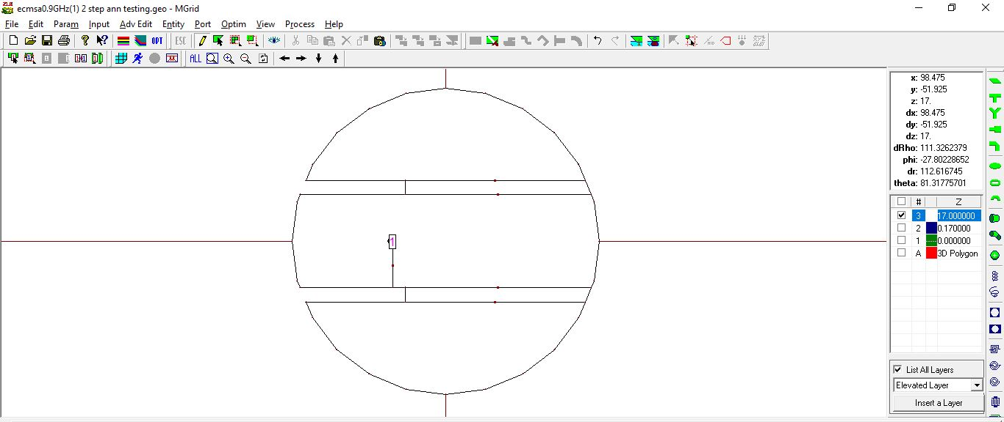

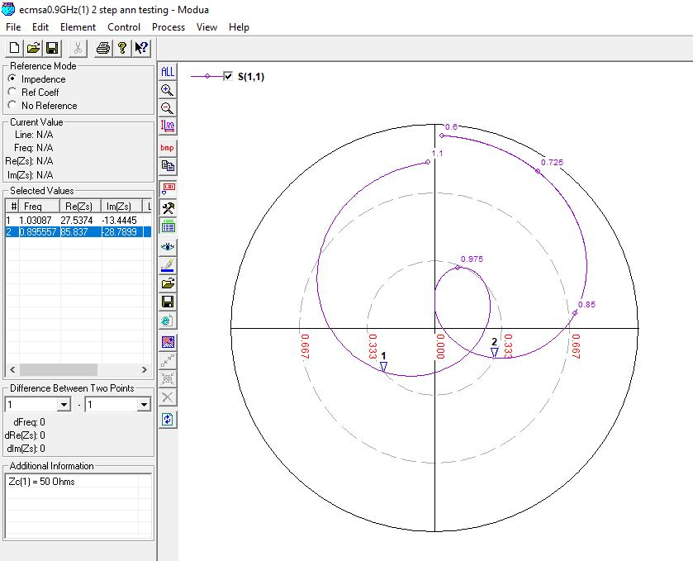

**900 MHz, 22 (0.07 lambda)**

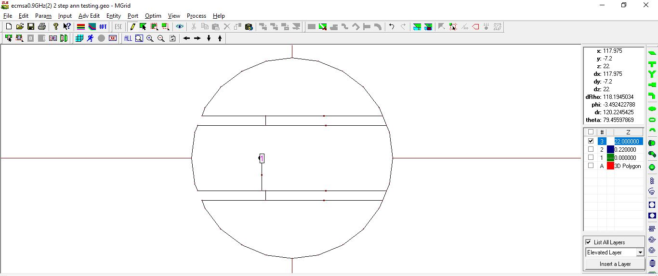

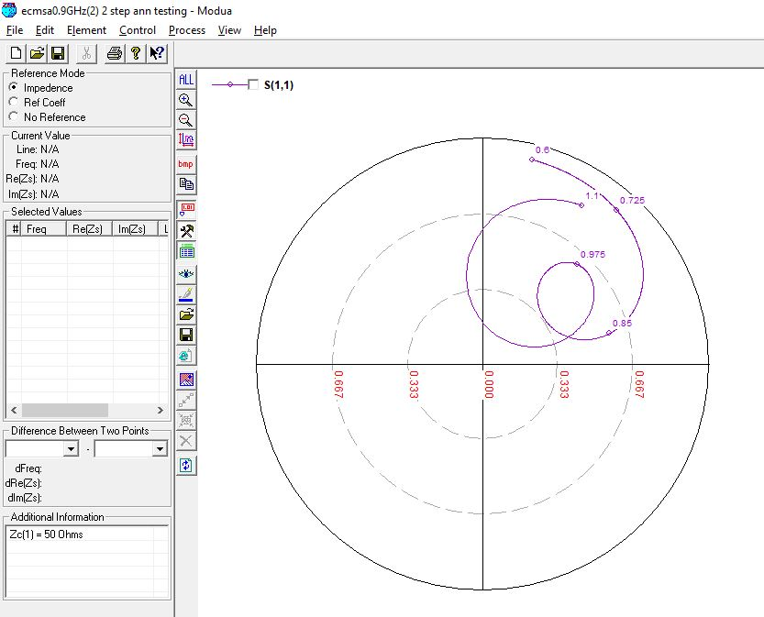

**1500 MHz, 11 (0.05 lambda)**

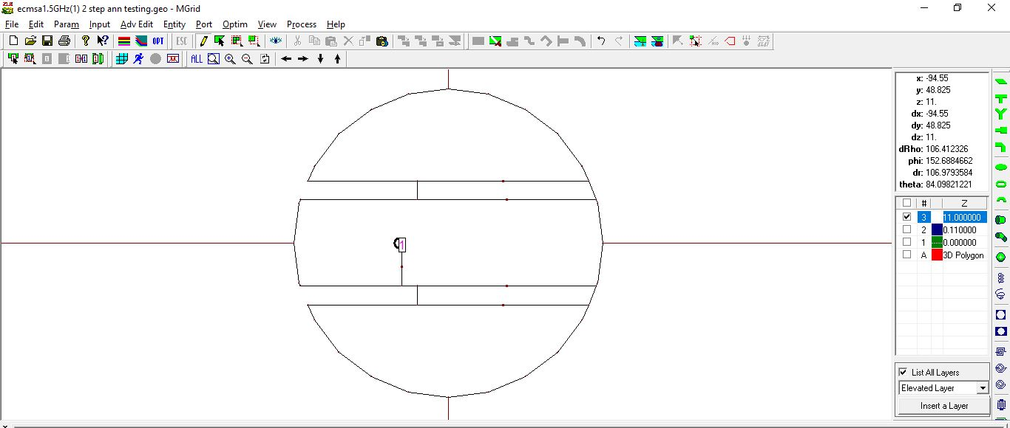

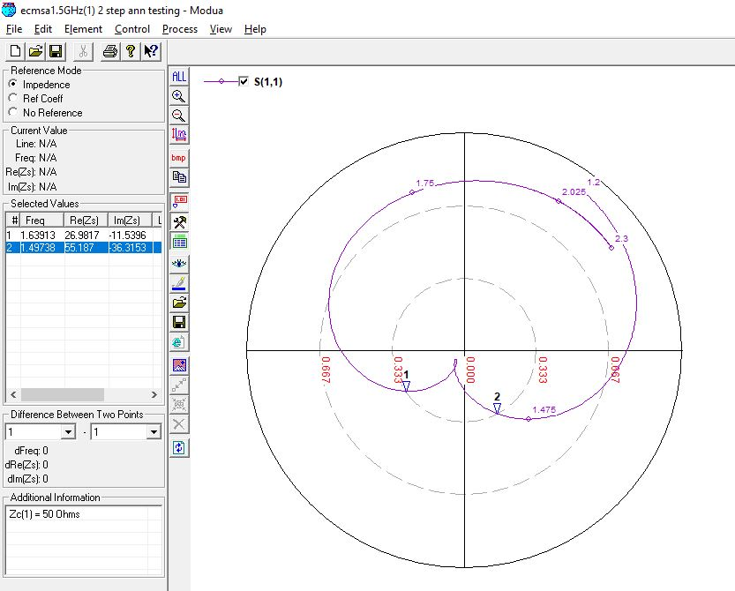

**1500 MHz, 11 (0.05 lambda) OPTIMIZED**

Initial values: Slot Length**: 40mm**

Optimized values: Slot Length**: 37mm**

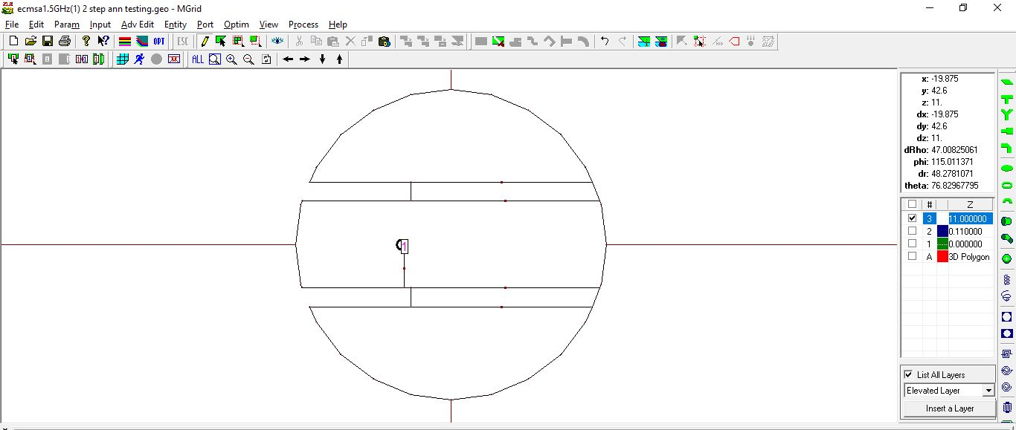

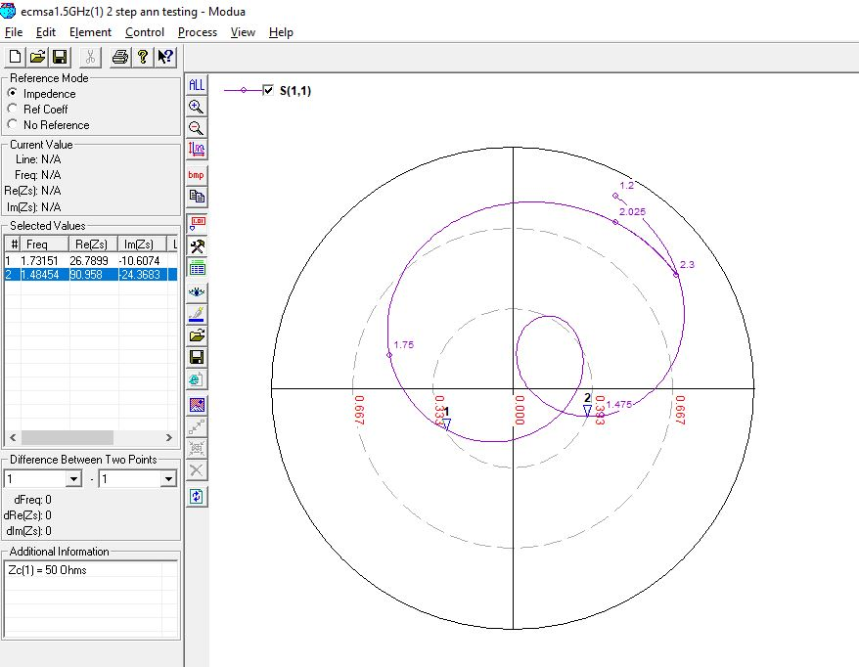

**1500 MHz, 14 (0.07 lambda)**

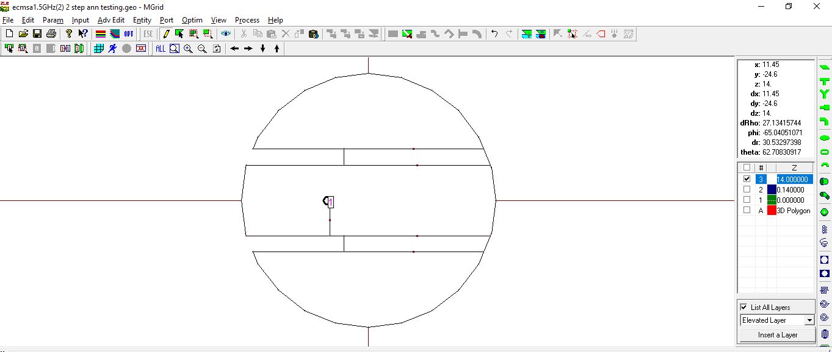

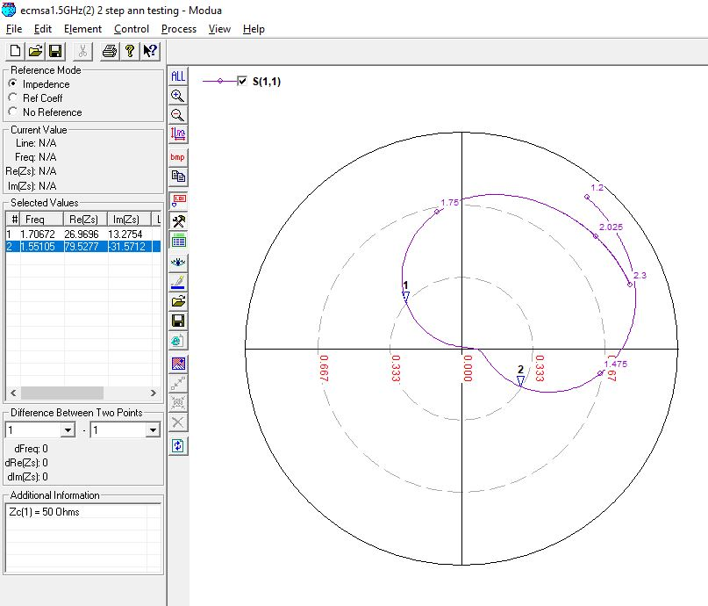

**1500 MHz, 14 (0.07 lambda) OPTIMIZED**

Initial values: Feed Position**: -14mm,** Slot Length**: 39mm**

Optimized values: Feed Position**: -15mm,** Slot Length**: 37mm**

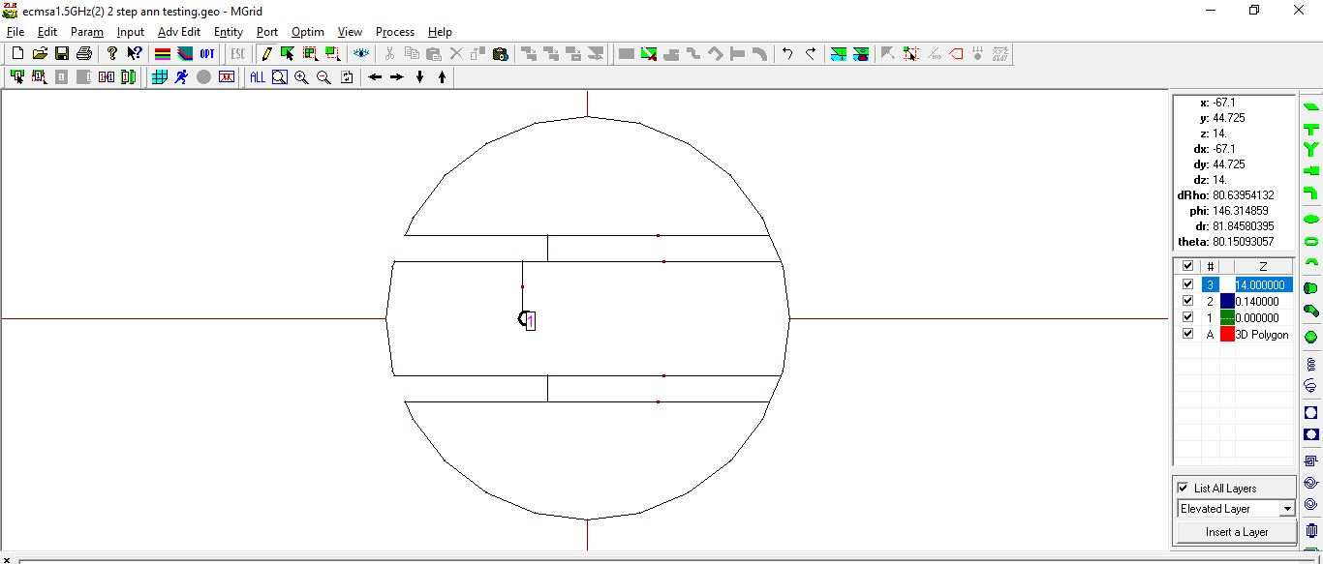

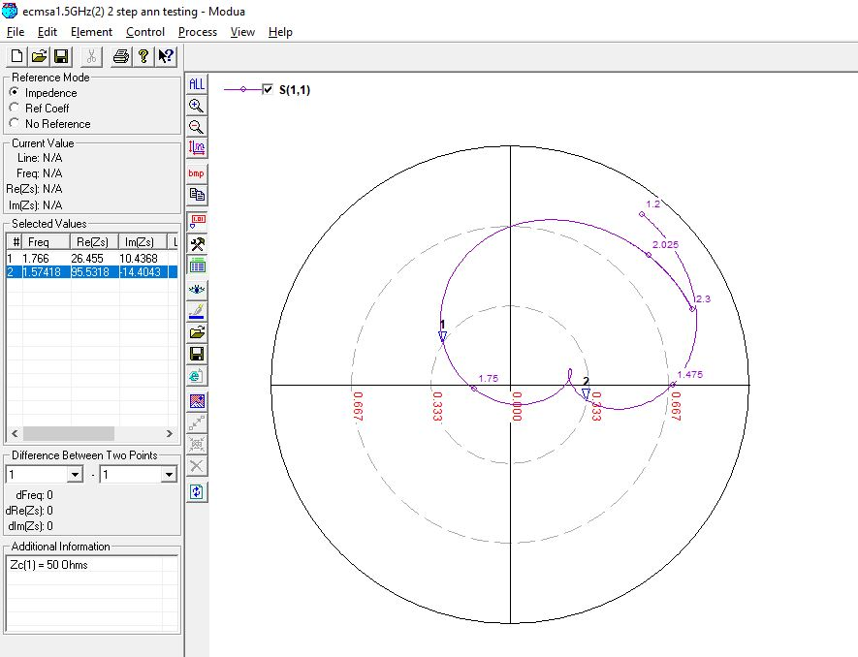

**2100 MHz, 8 (0.05 lambda)**

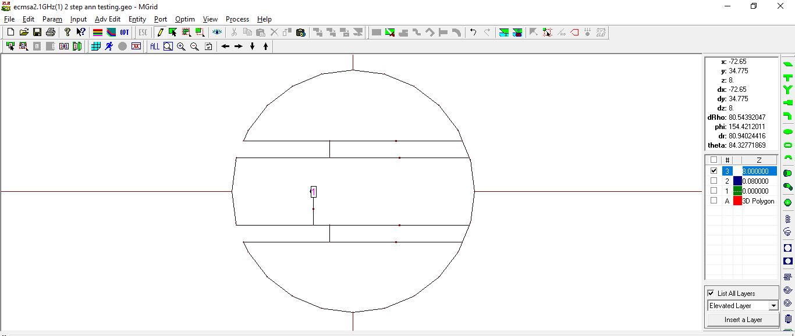

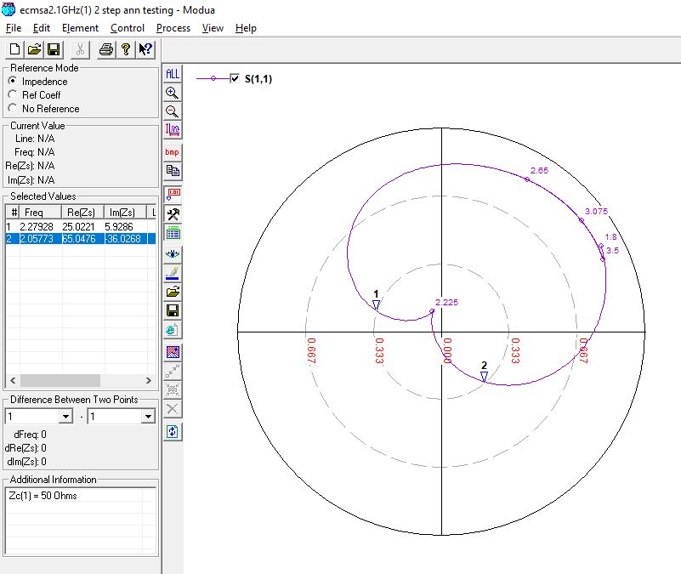

**2100 MHz, 8 (0.05 lambda) OPTIMIZED**

Initial values: Feed Position**: -12mm,** Slot Length**: 29mm**

Optimized values: Feed Position**: -14mm**, Slot Length**: 27mm**

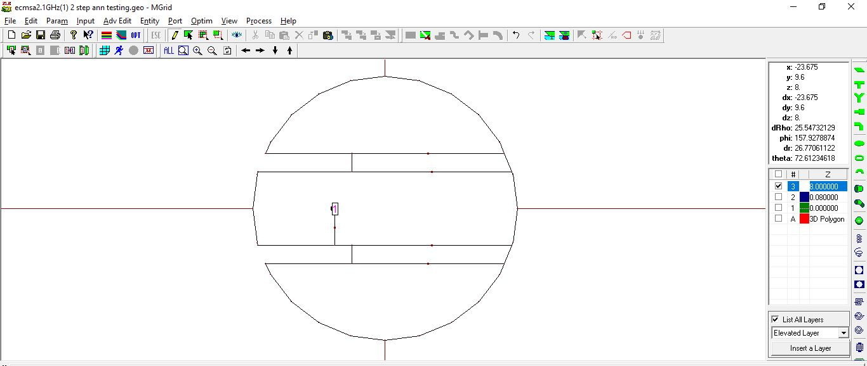

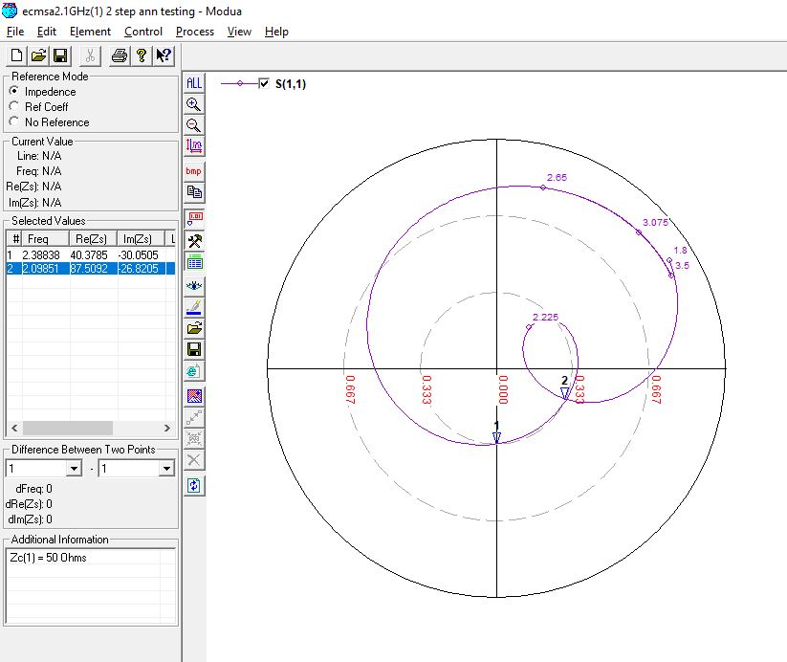

**2100 MHz, 10 (0.07 lambda)**

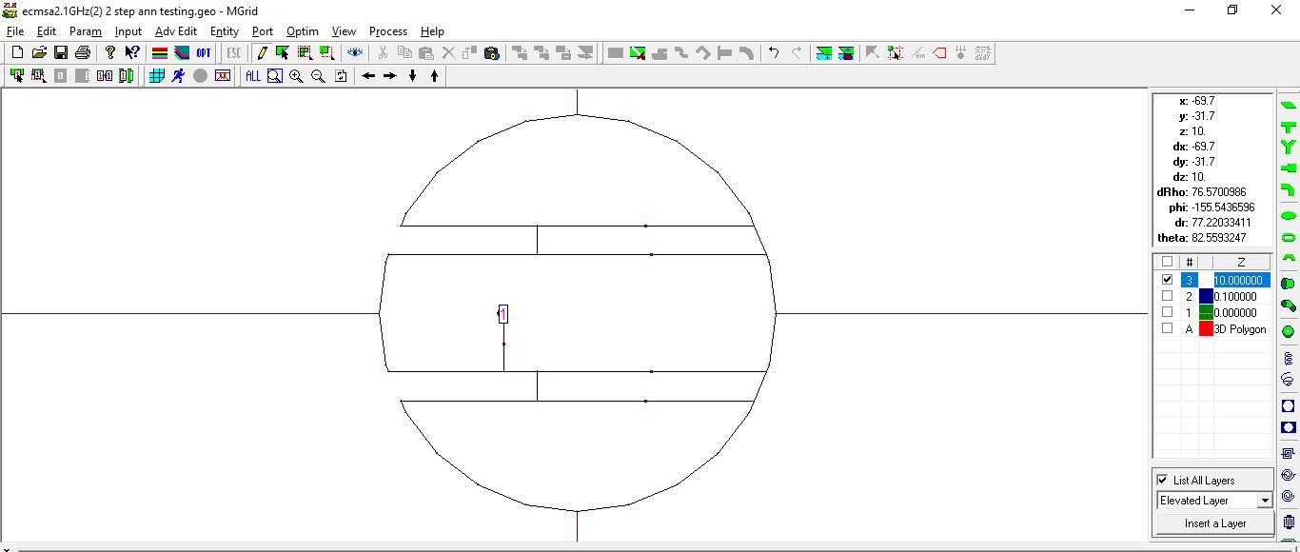

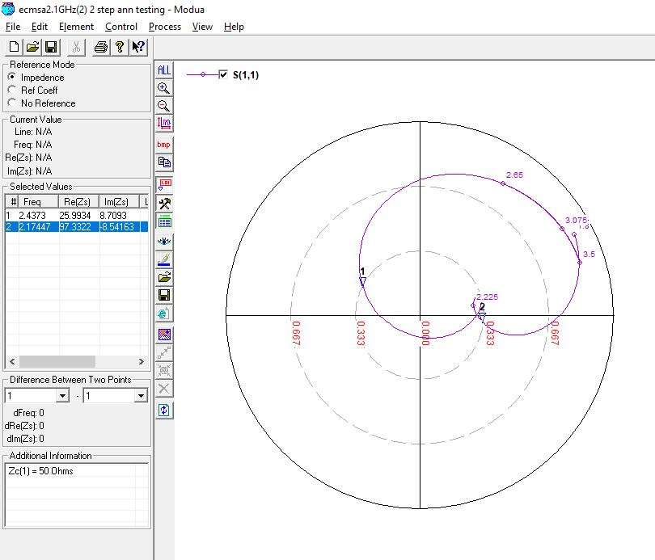

**2700 MHz, 6 (0.05 lambda)**

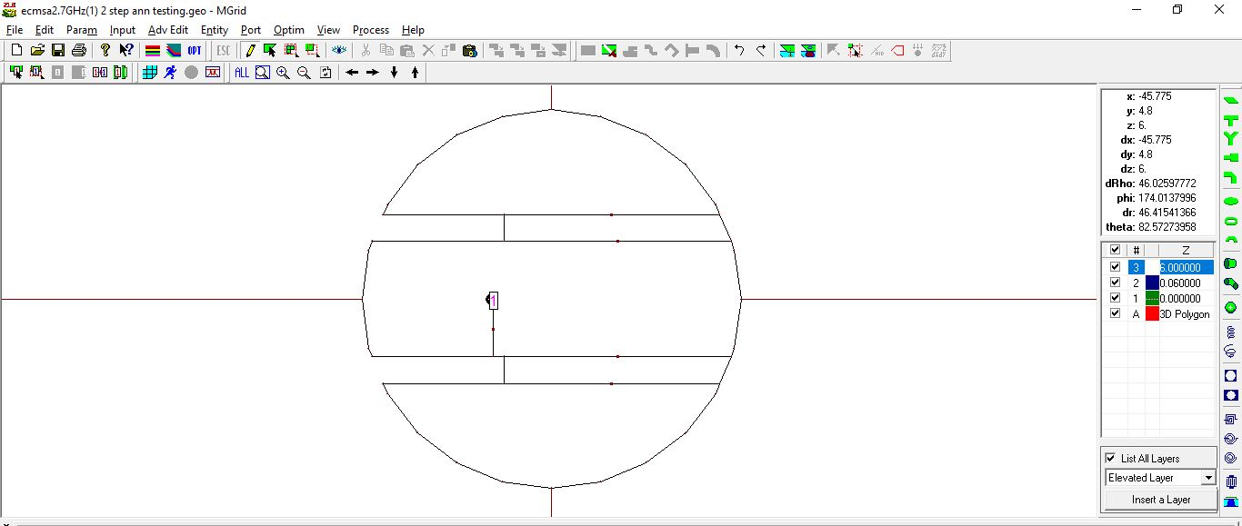

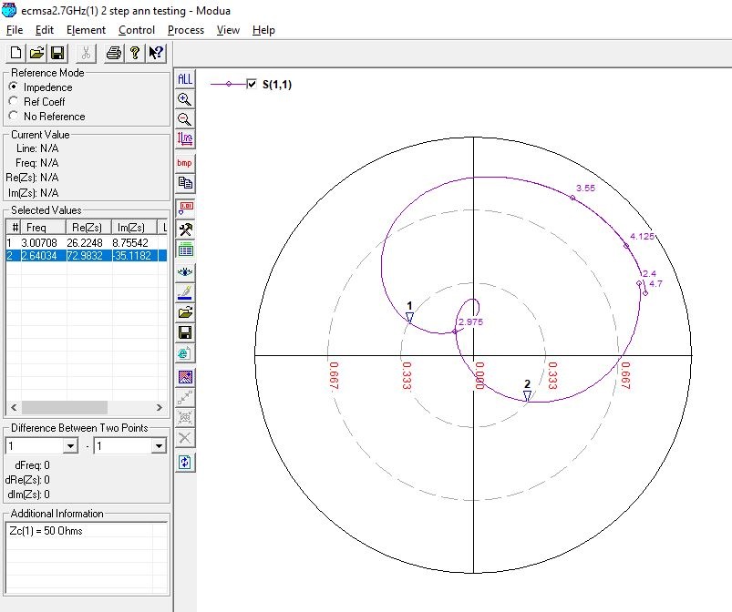

**2700 MHz, 6 (0.05 lambda) OPTIMIZED**

Initial values: Feed Position**: -9mm**

Optimized values: Feed Position**: -11mm**

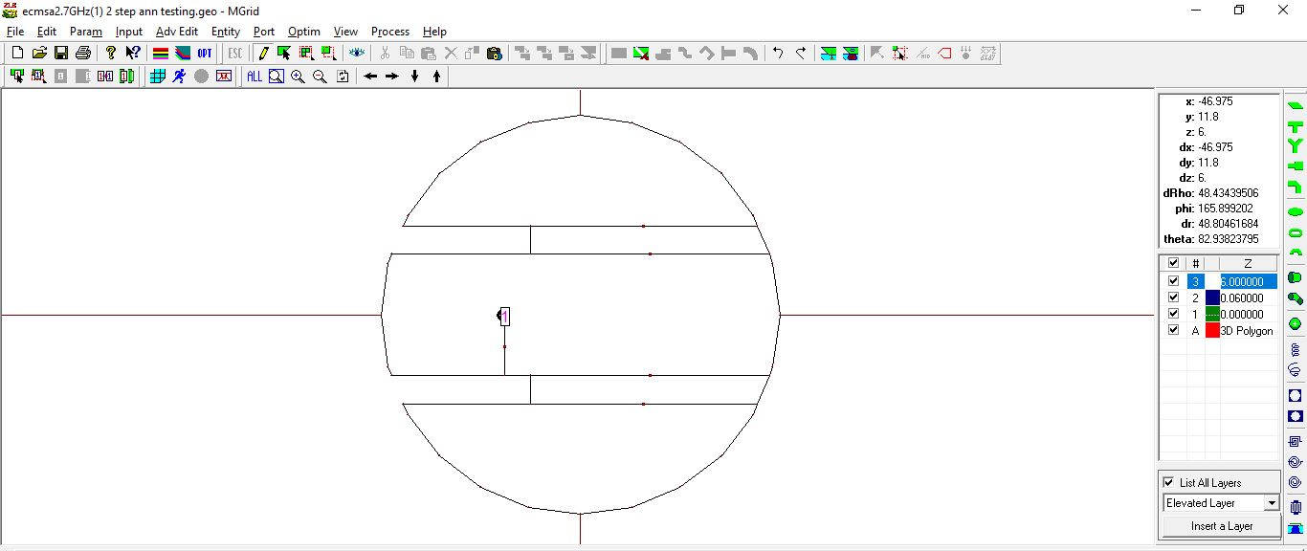

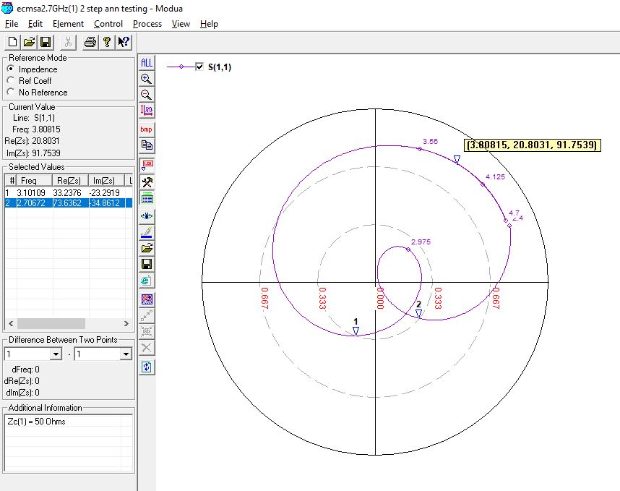

**2700 MHz, 7 (0.07 lambda)**

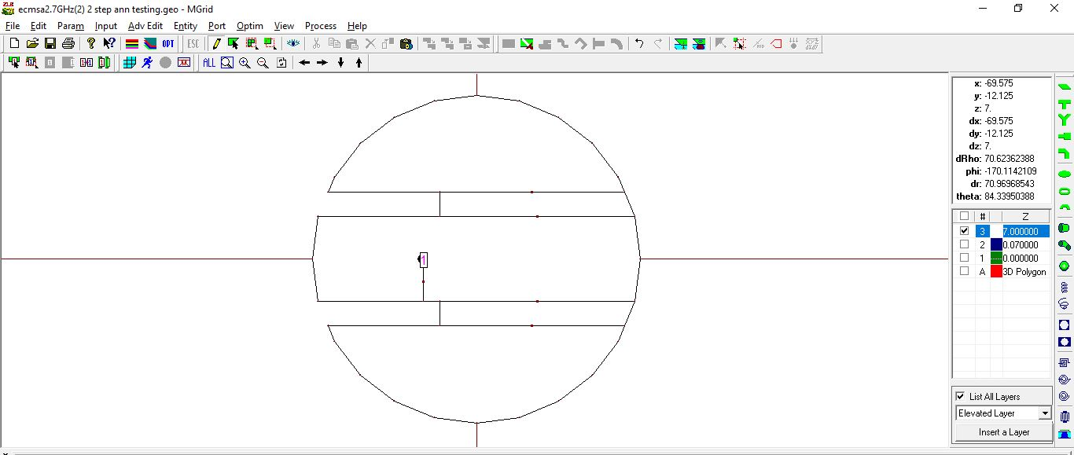

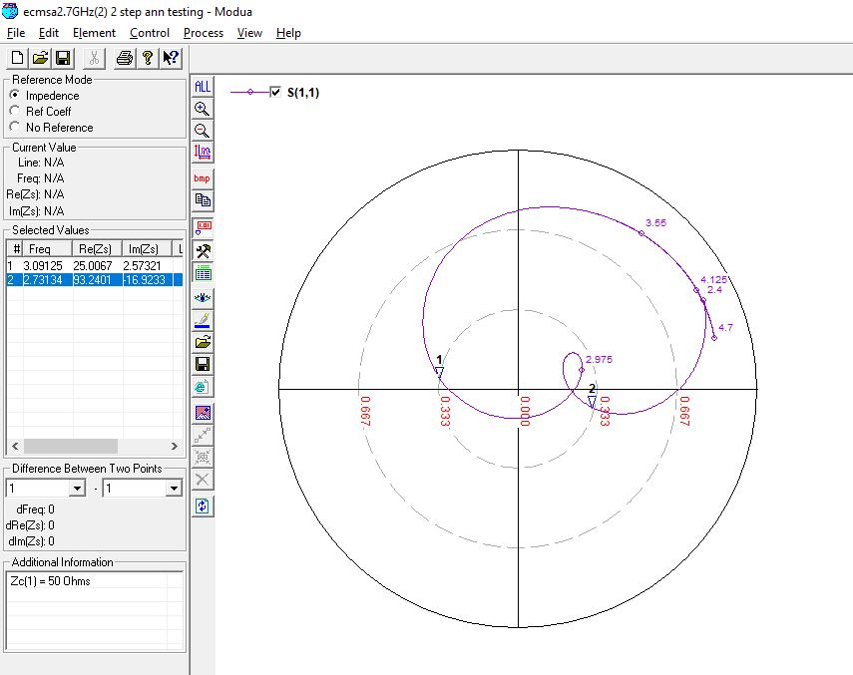

**3300 MHz, 5 (0.05 lambda)**

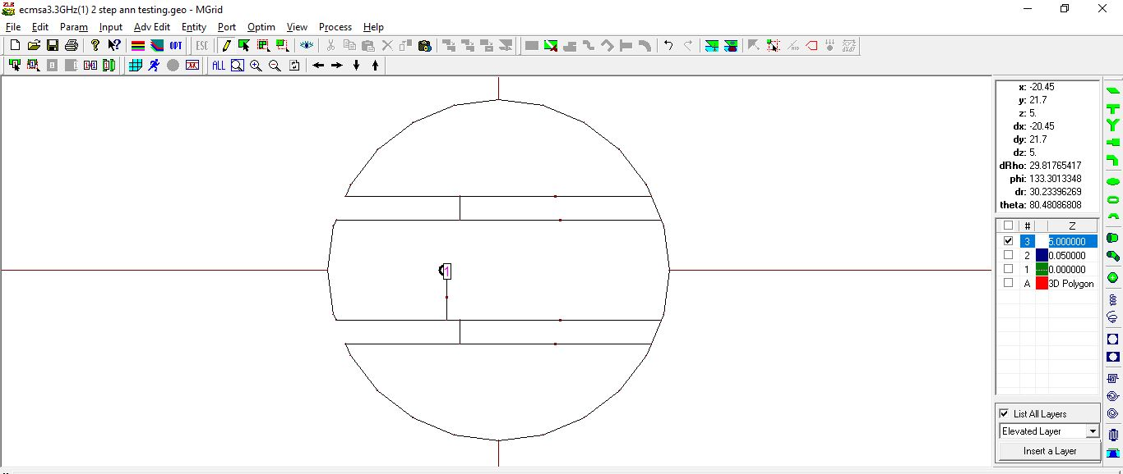

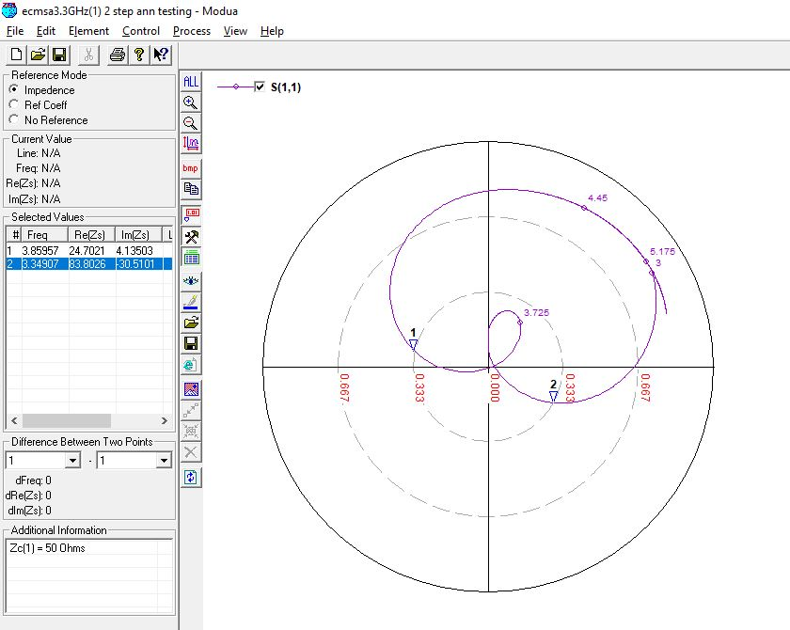

**3300 MHz, 5 (0.05 lambda) OPTIMIZED**

Initial values: Feed Position**: -7mm**

Optimized values: Feed Position**: -8mm**

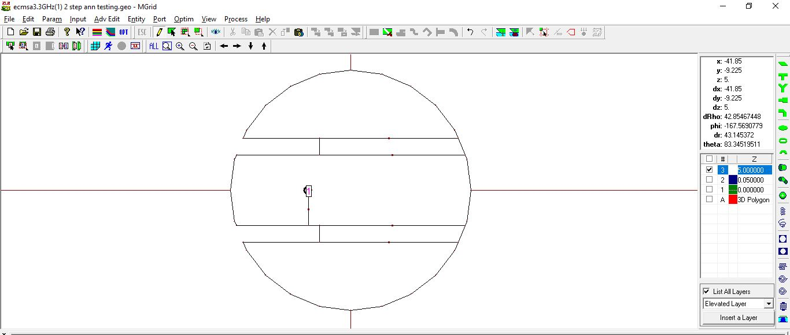

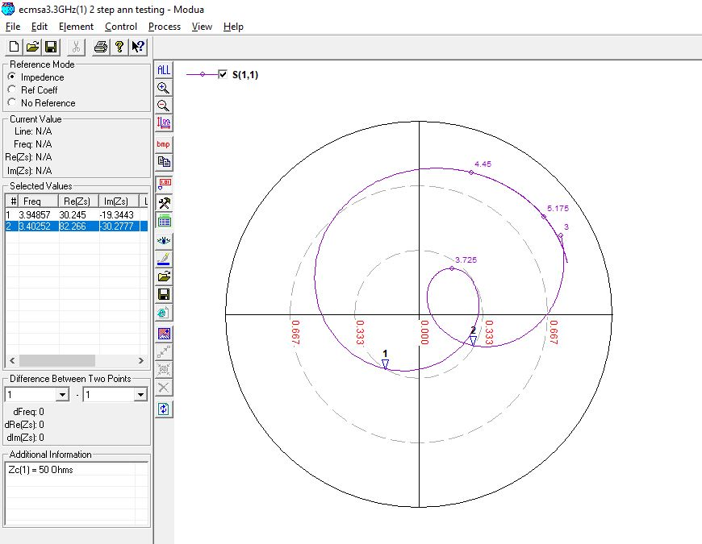

**3300 MHz, 6 (0.07 lambda)**

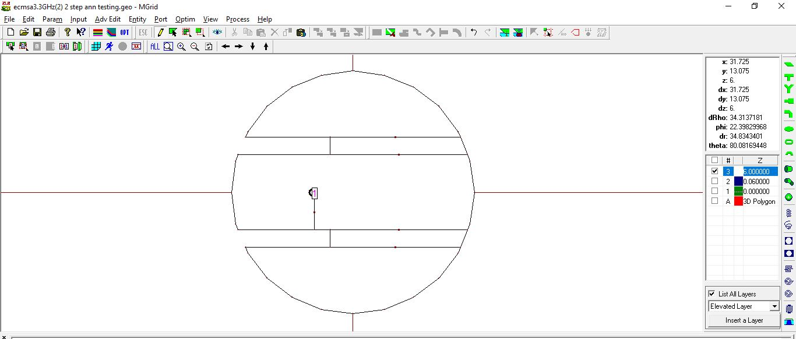

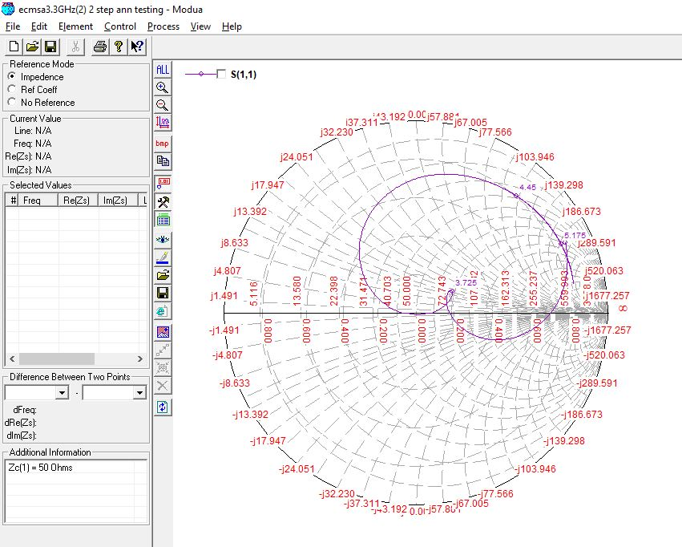

**3300 MHz, 6 (0.07 lambda) OPTIMIZED**

Initial values: Feed Position**: -7mm**

Optimized values: Feed Position**: -8mm**

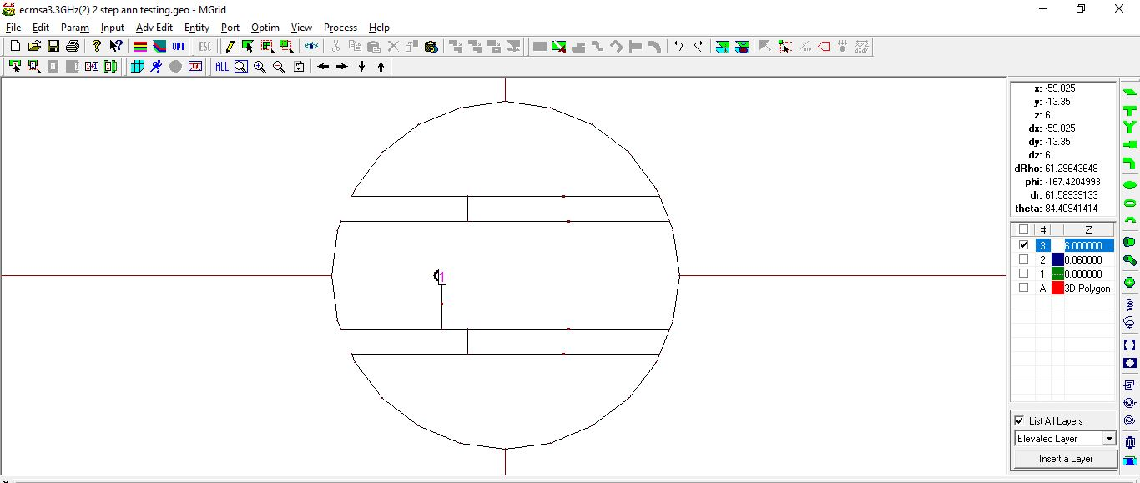

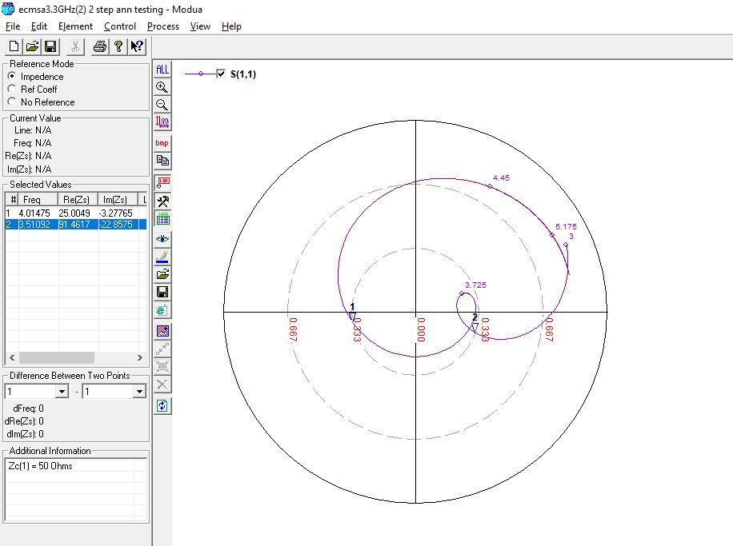

**3900 MHz, 4 mm (0.05 lambda)**

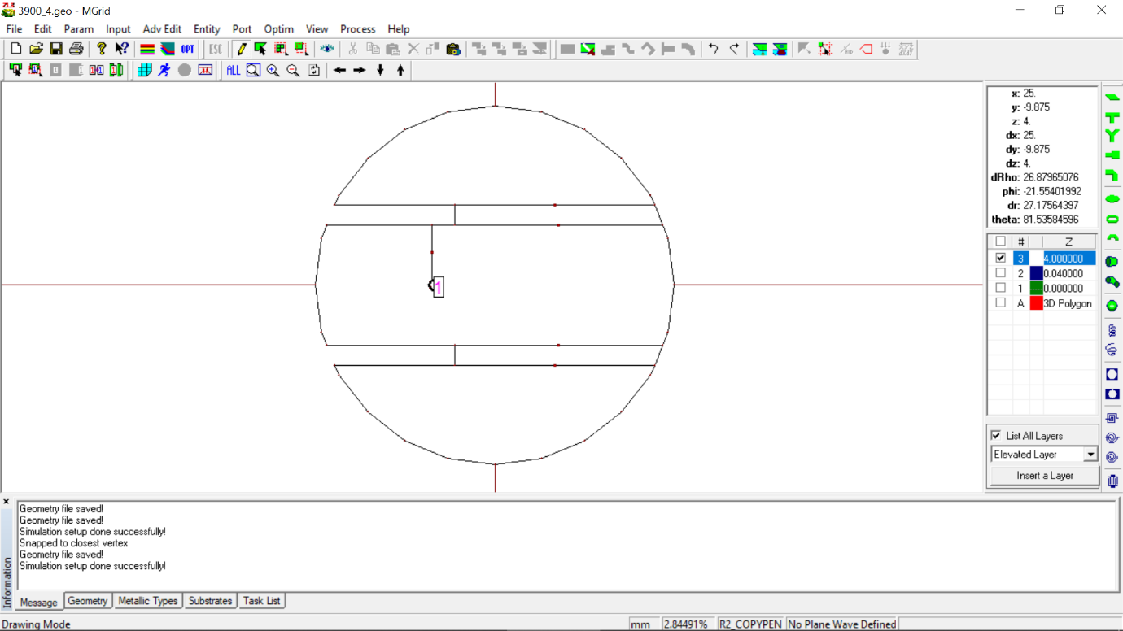

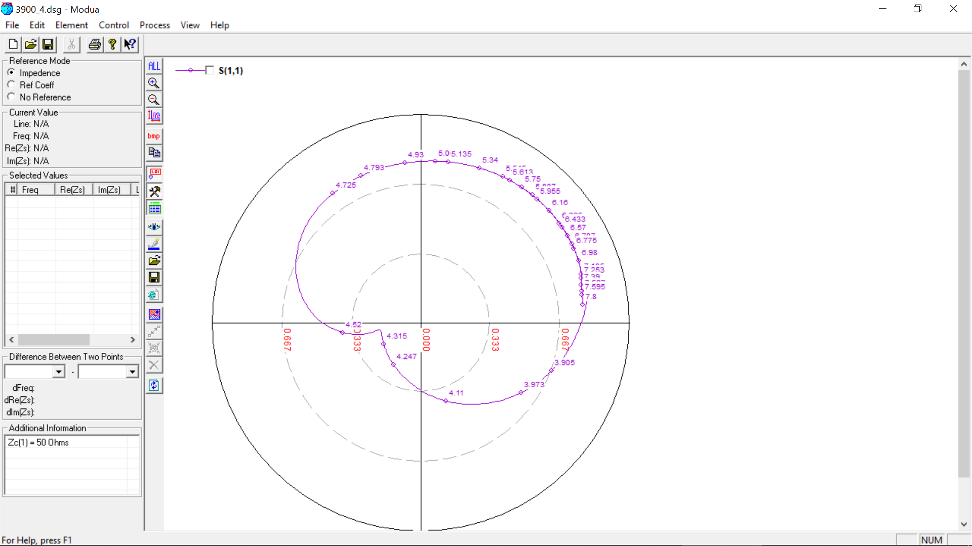

**3900 MHz, 4 mm (0.05 lambda) OPTIMIZED**

Original value: slot length **= 15 mm**

Optimized value: slot length **= 14 mm**



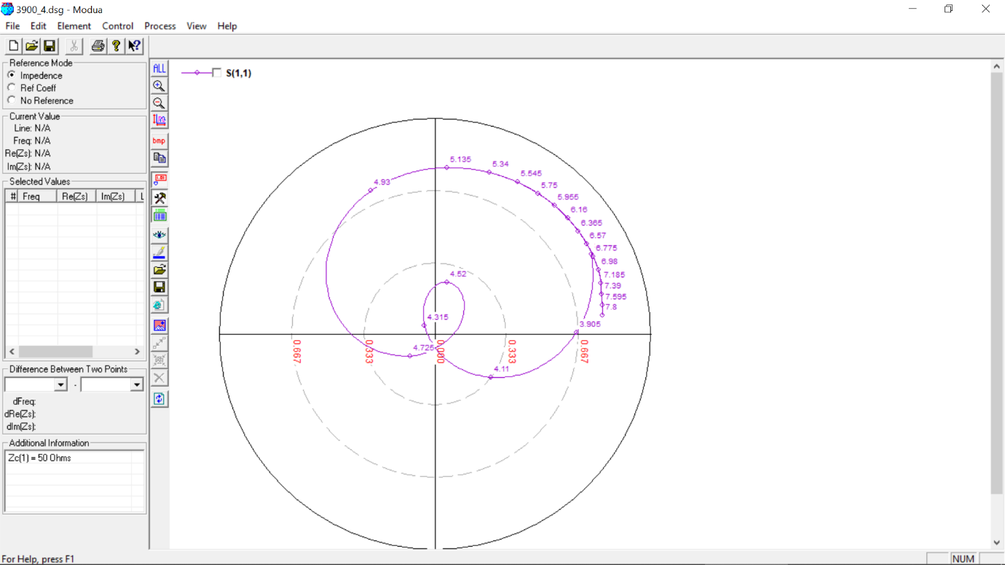

**3900 MHz, 5 mm (0.07 lambda)**

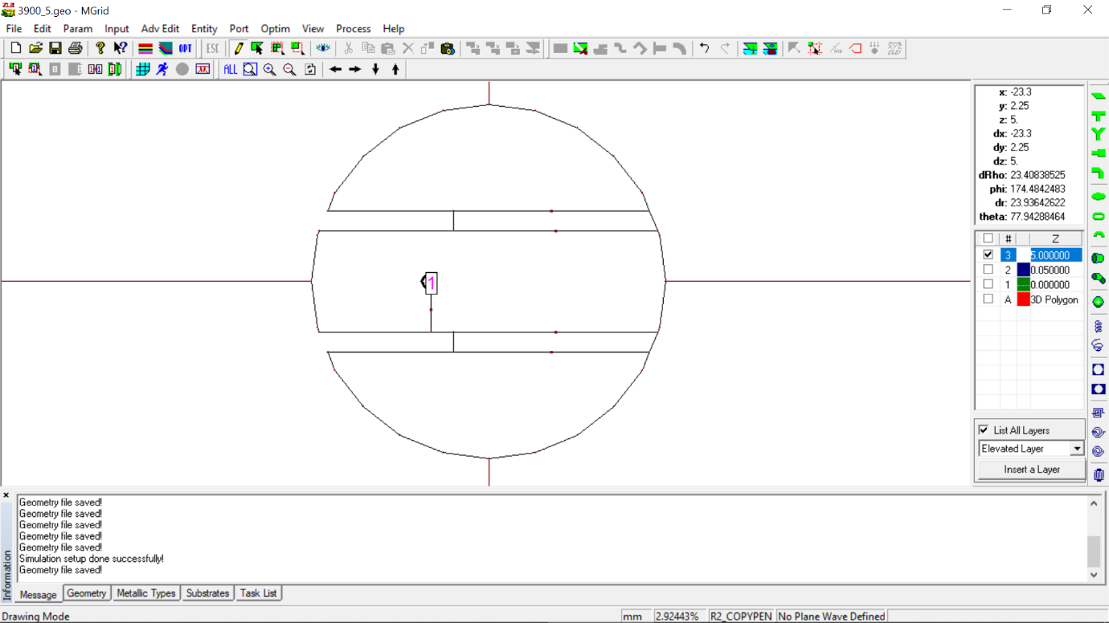

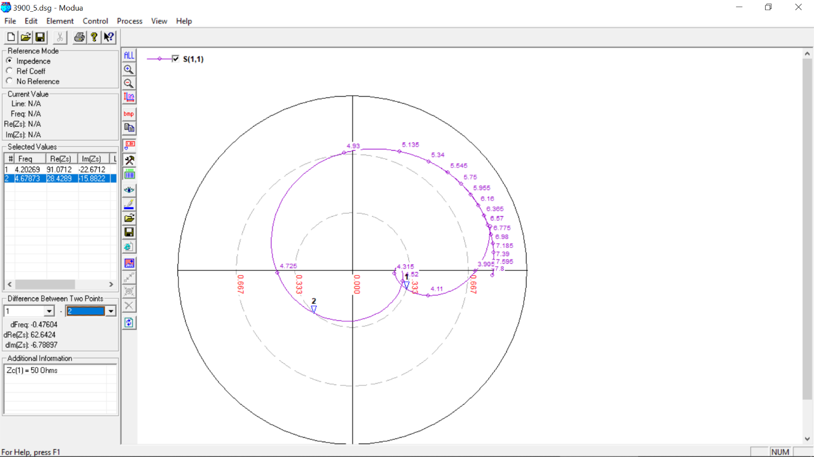

**4300 MHz, 4 mm (0.05 lambda)**

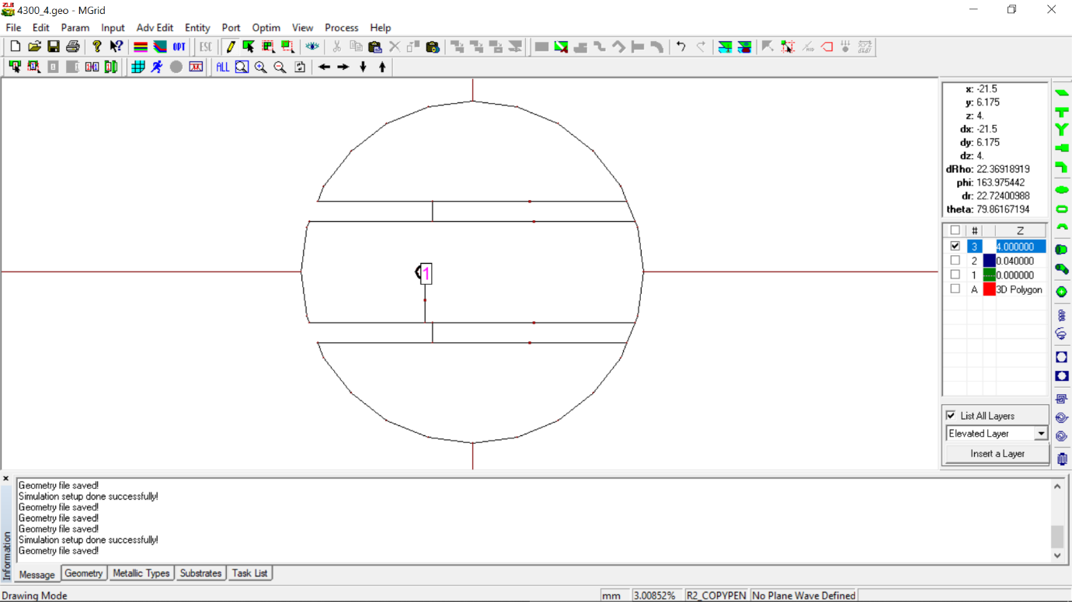

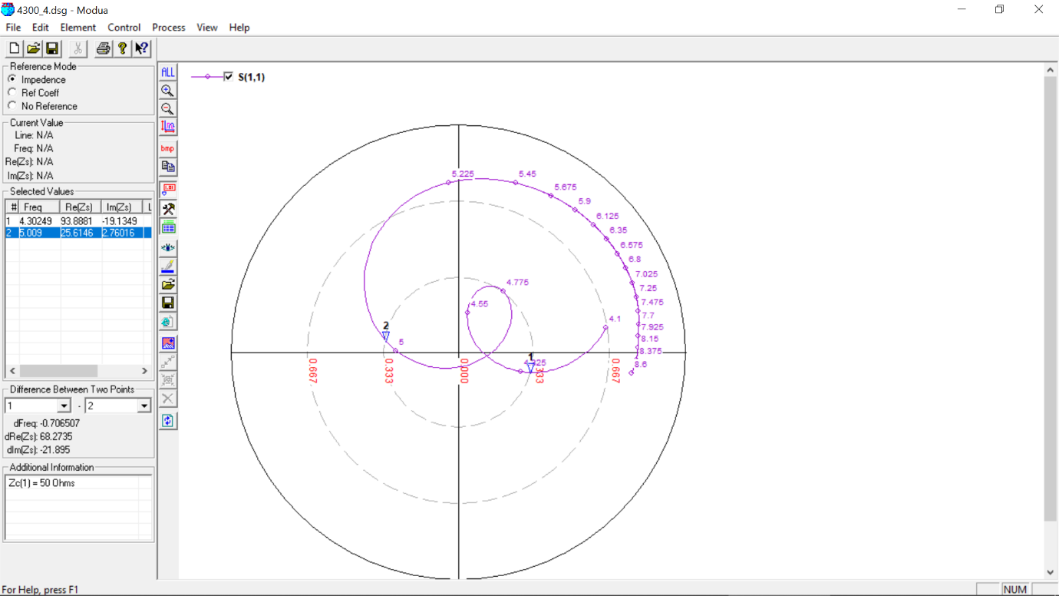

**4300 MHz, 5 mm (0.07 lambda)**

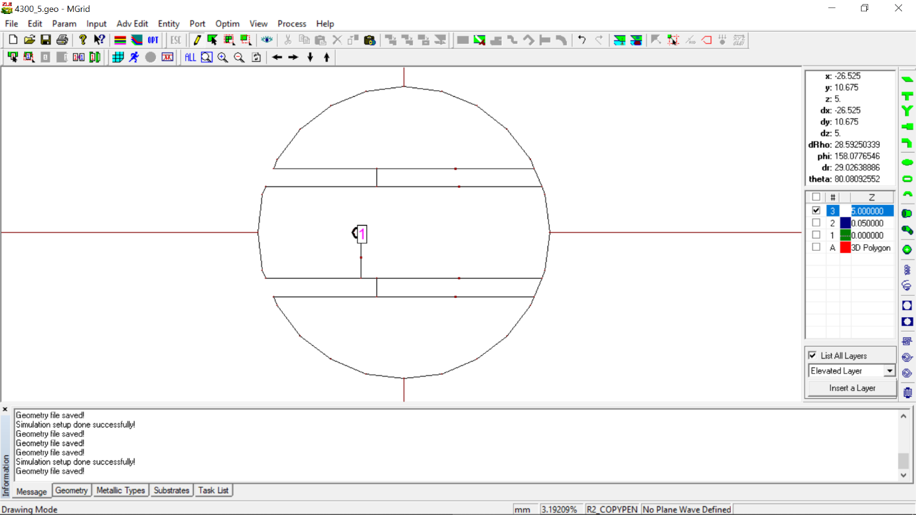

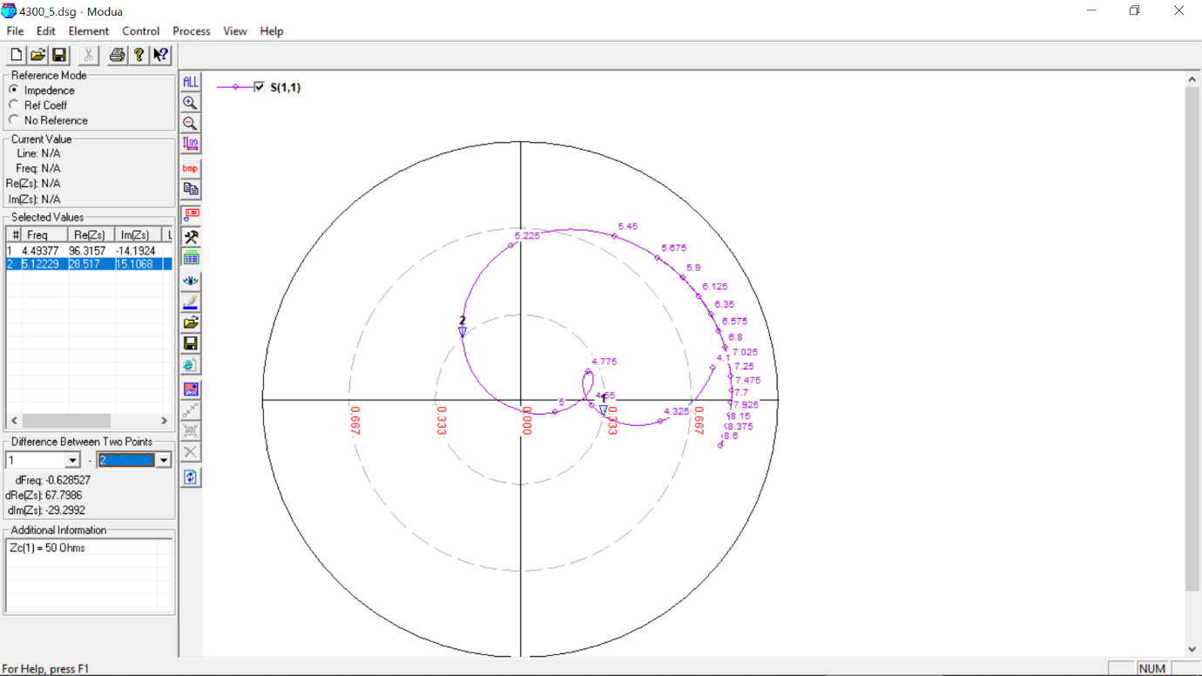

**4900 MHz, 4 mm (0.05 lambda)**

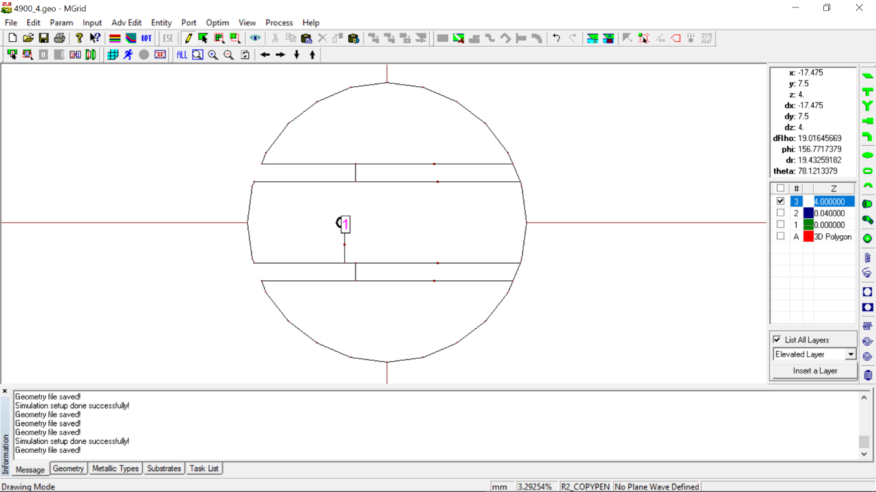

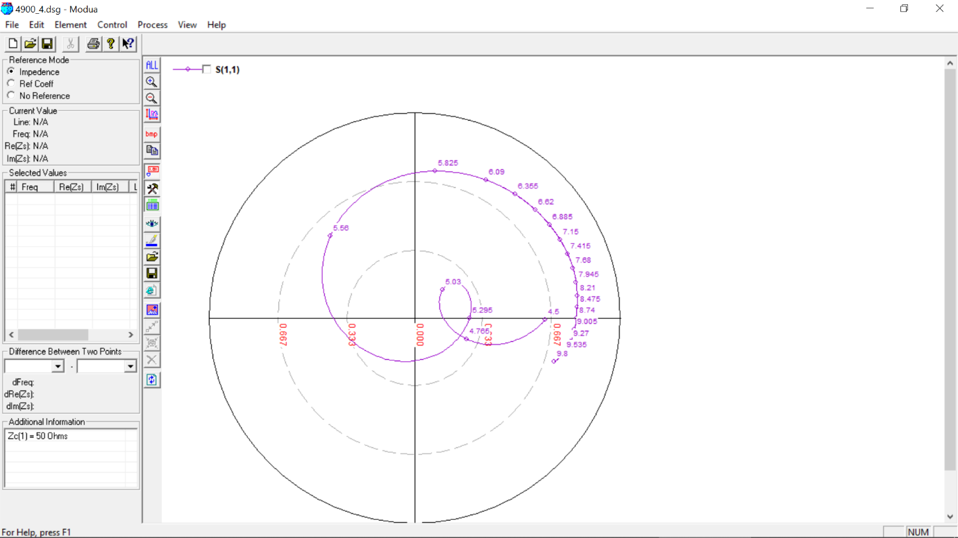

**4900 MHz, 4 mm (0.07 lambda)**

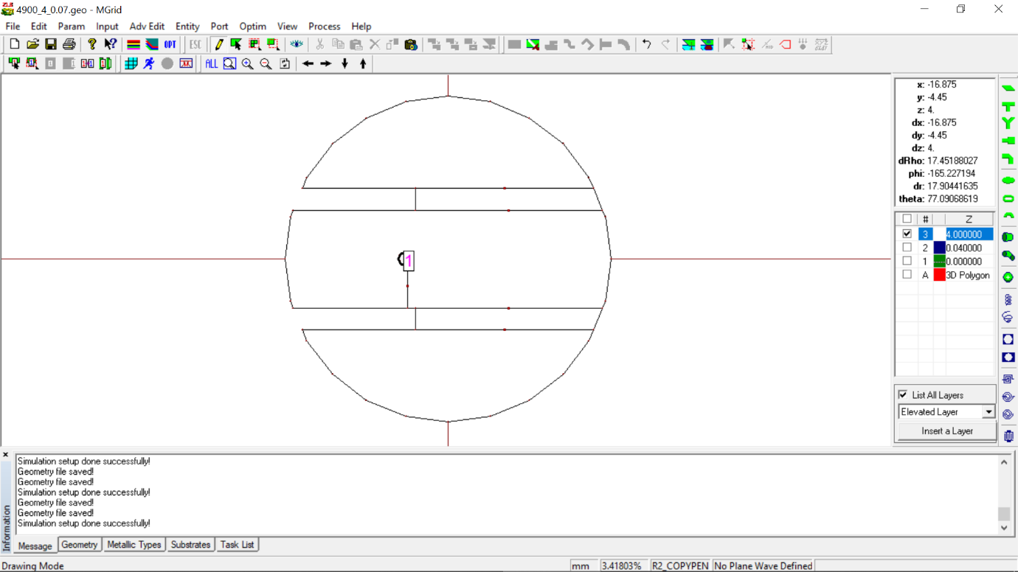

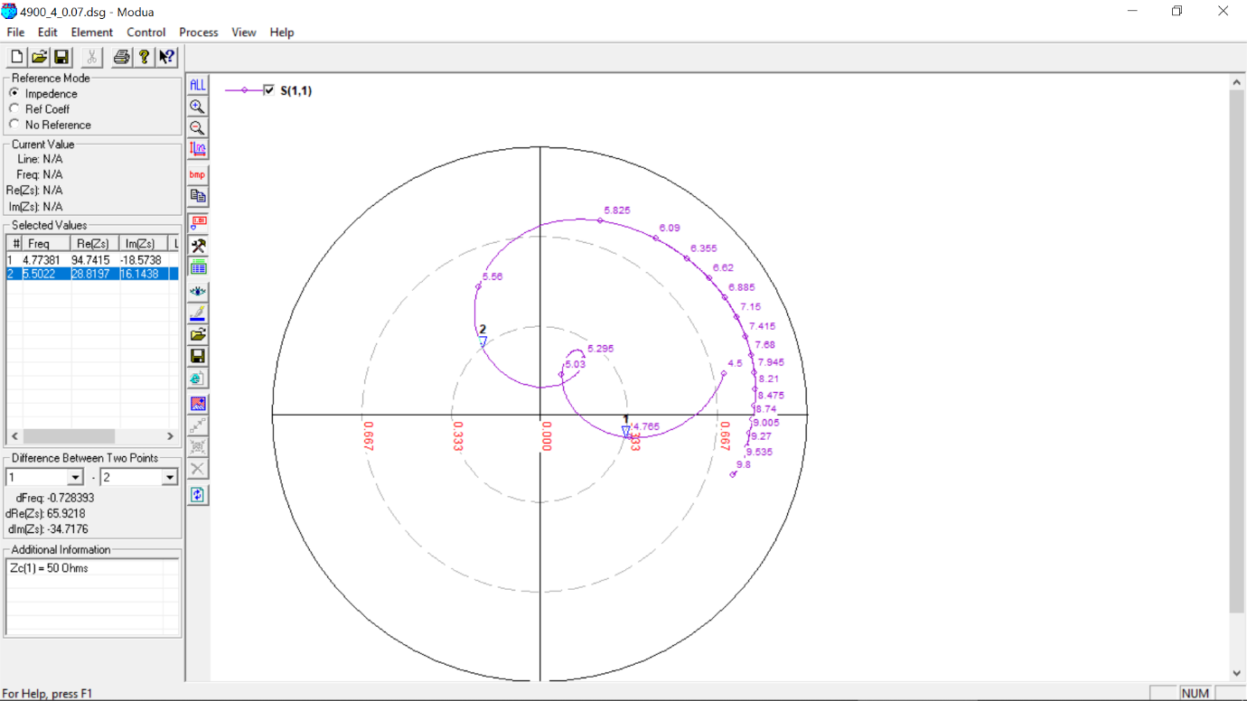

**5100 MHz, 3 mm (0.05 lambda)**

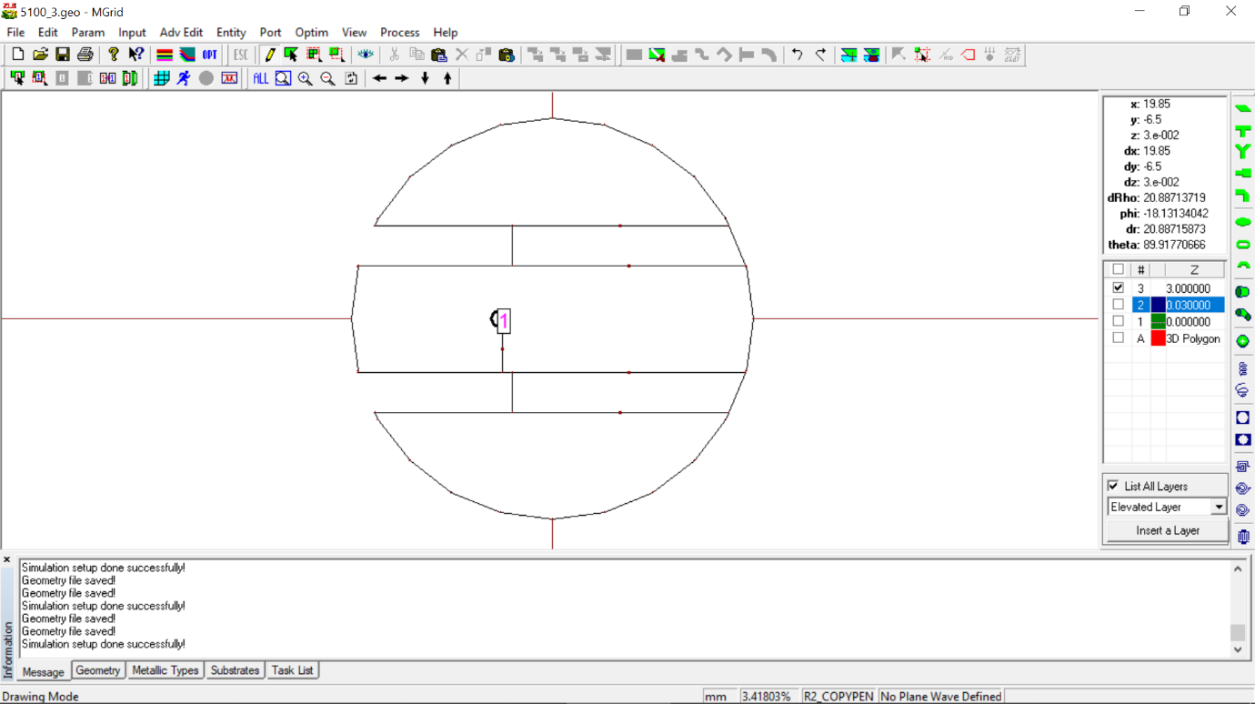

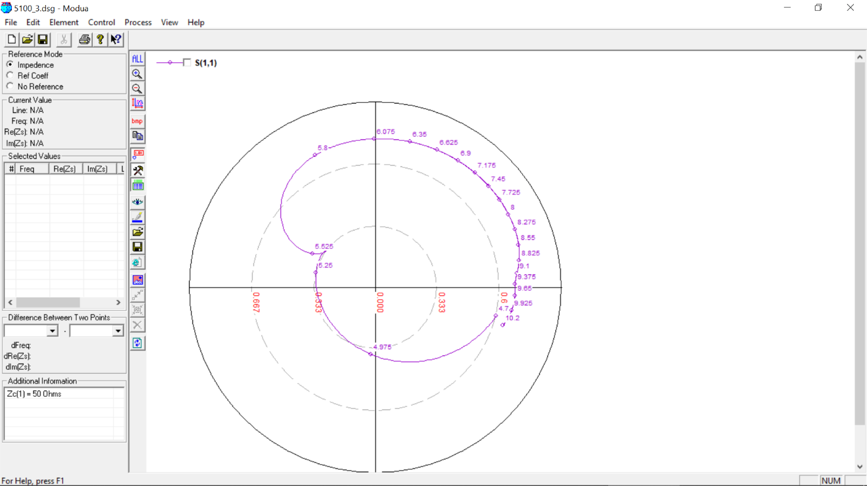

**5100 MHz, 3 mm (0.05 lambda) OPTIMIZED**

Original value: slot length **= 12 mm,** Feed position**: -4,** slot width **= 3mm**

Optimized value: slot length **= 11 mm,** Feed position**: -5,** slot width **= 2mm**

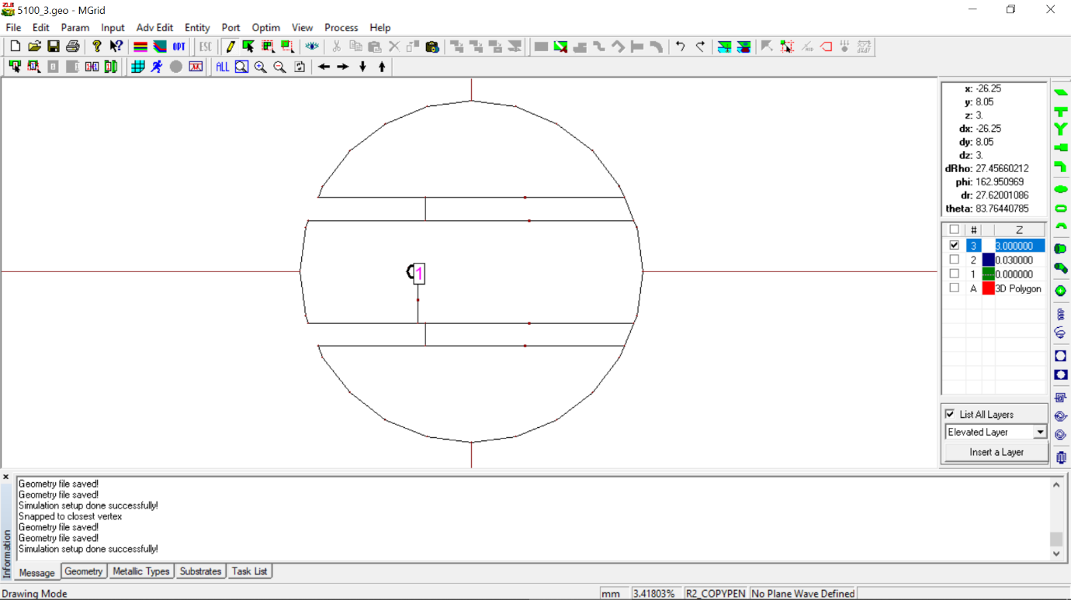

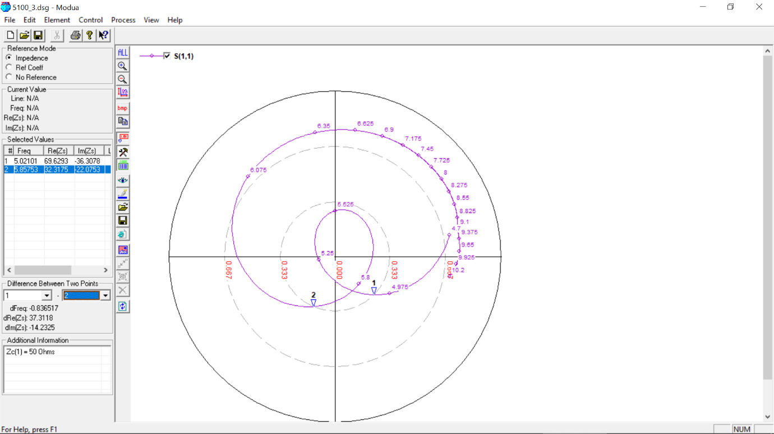

**5100 MHz, 4 mm (0.07 lambda)**

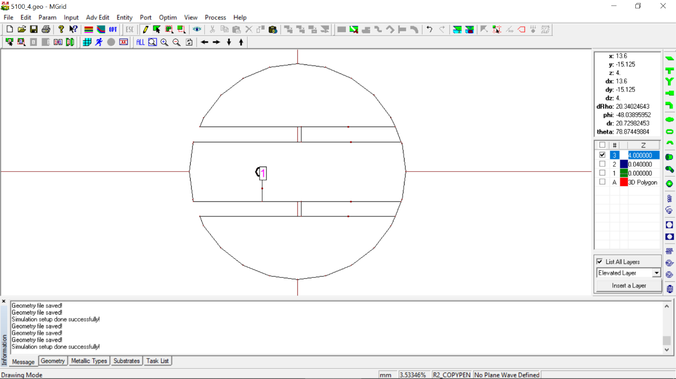

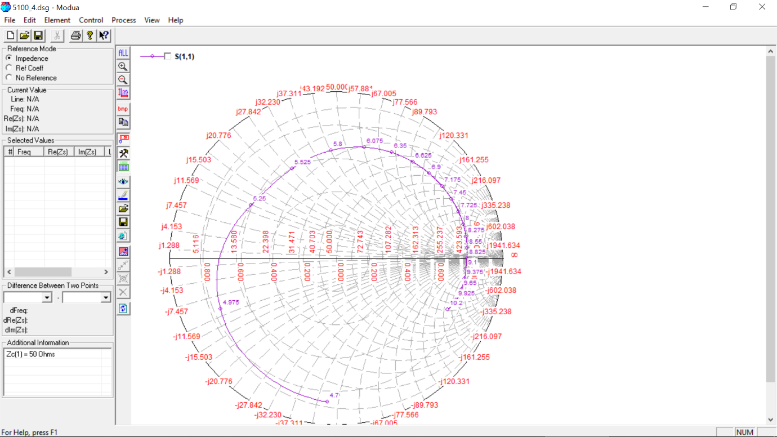

**5100 MHz, 4 mm (0.07 lambda) OPTIMIZED**

Original value: slot length **= 15 mm,** Feed position**: -5**

Optimized value: slot length **= 11.5 mm,** Feed position**: -4**

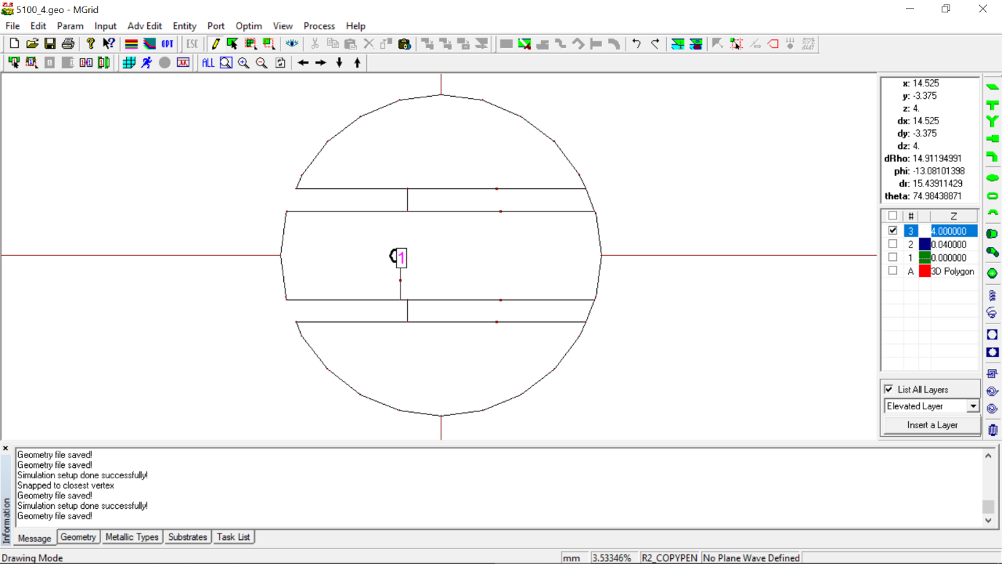

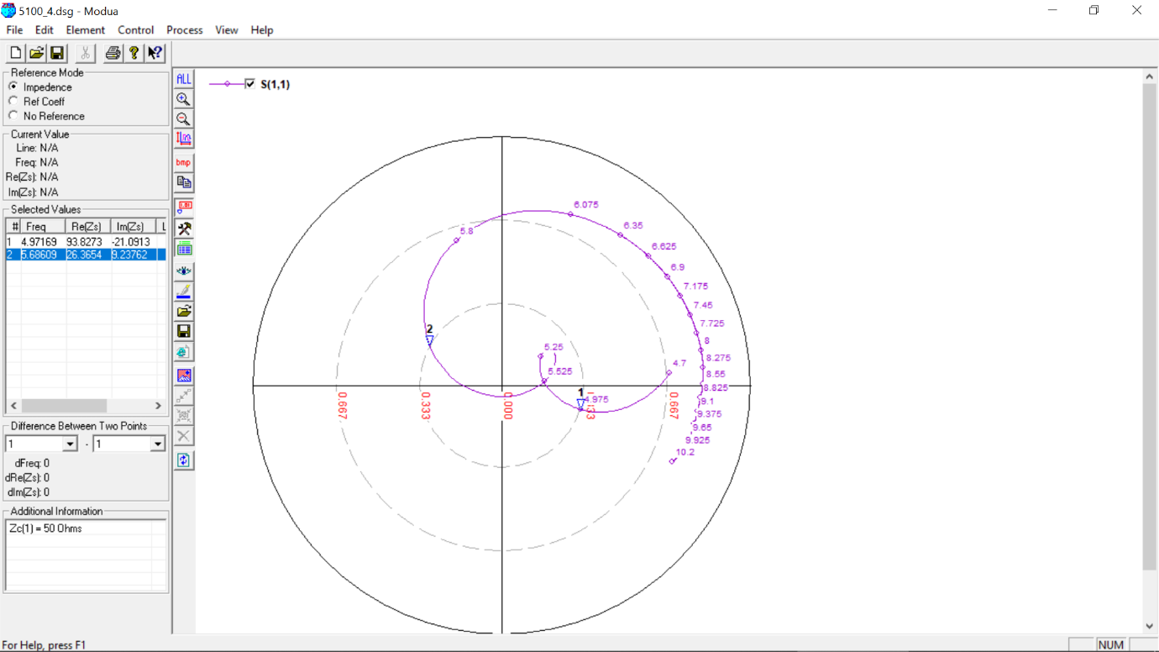

**5500 MHz, 3 mm (0.05 lambda)**

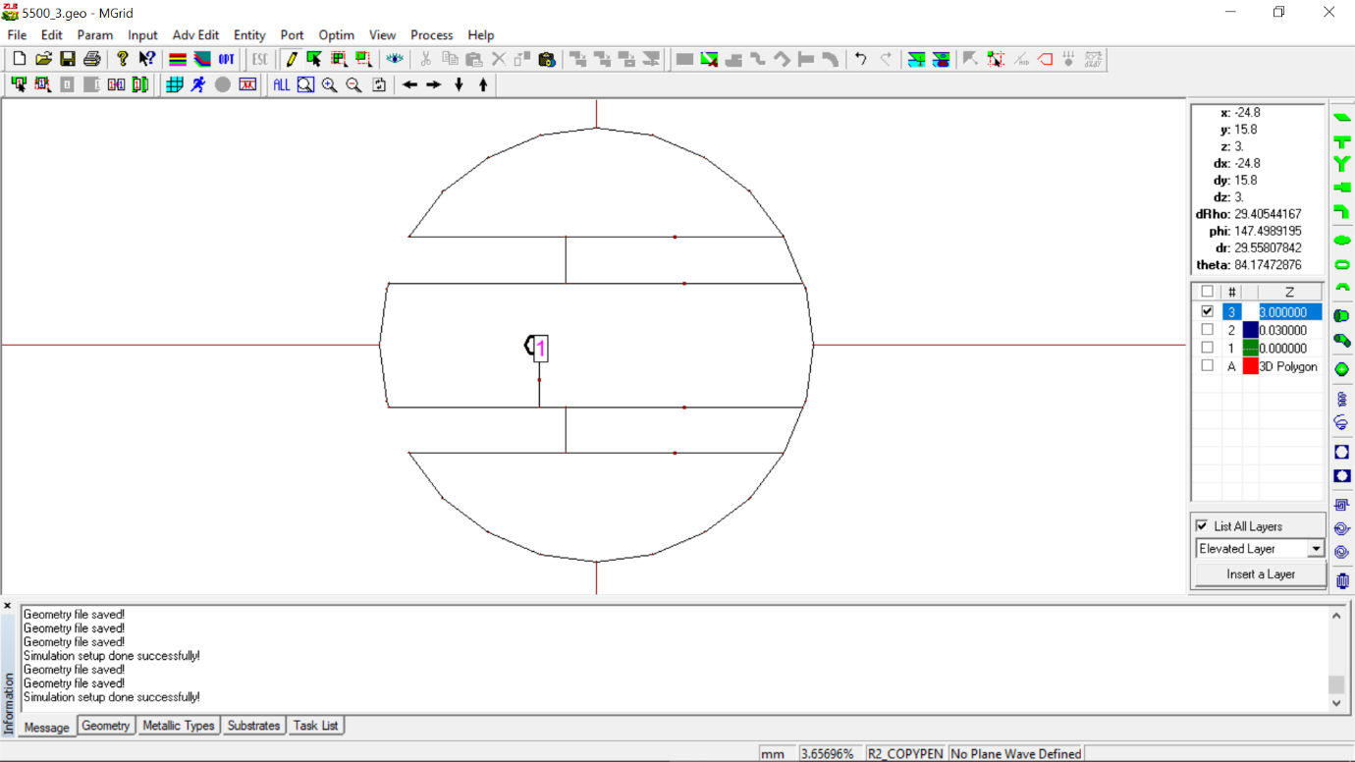

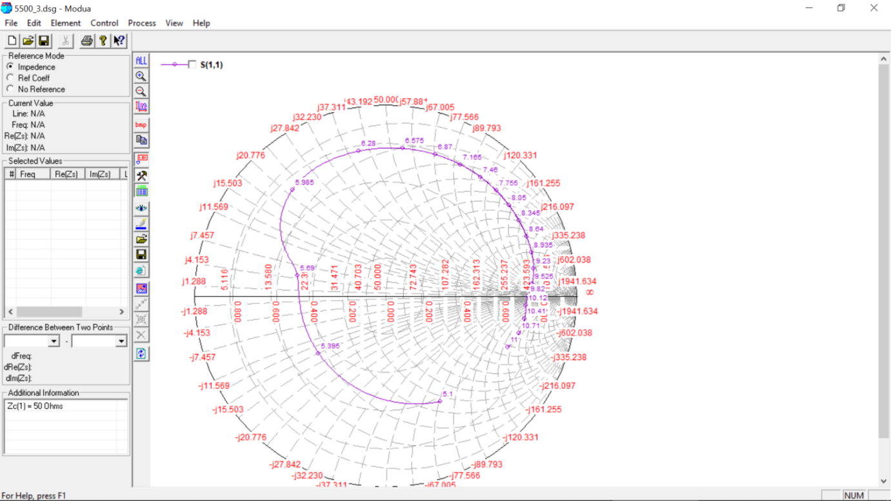

**5500 MHz, 3 mm (0.05 lambda) OPTIMIZED**

Original value: slot length **= 12 mm,** Feed position**: -4,** slot width **= 3mm**

Optimized value: slot length **= 11 mm,** Feed position**: -5,** slot width **= 2mm**

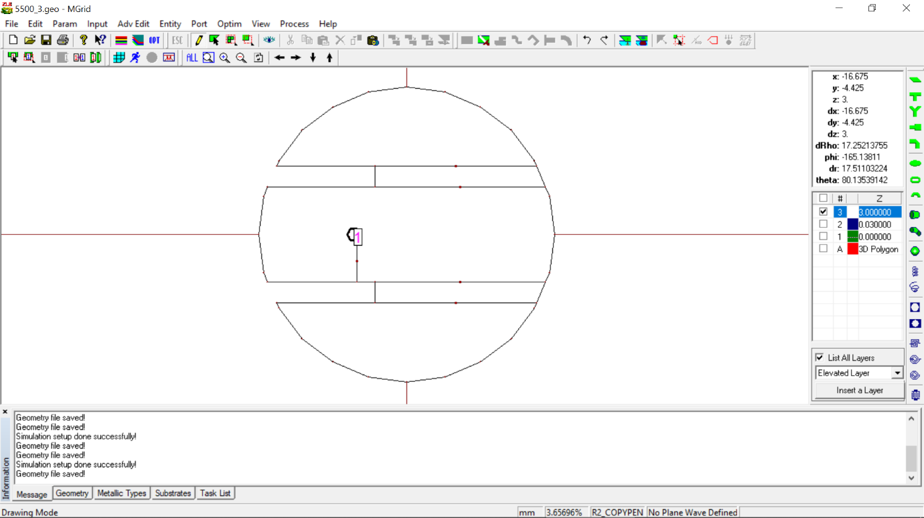

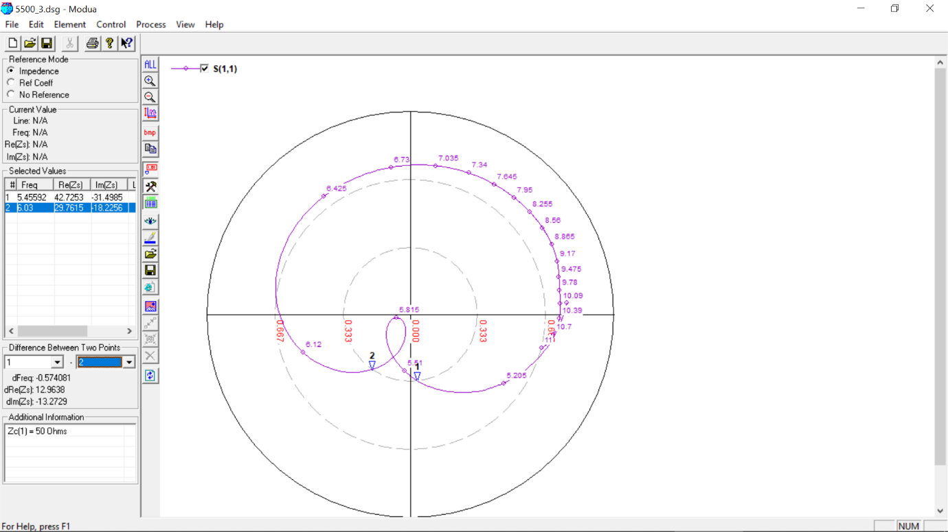

**5500 MHz, 4 mm (0.07 lambda)**

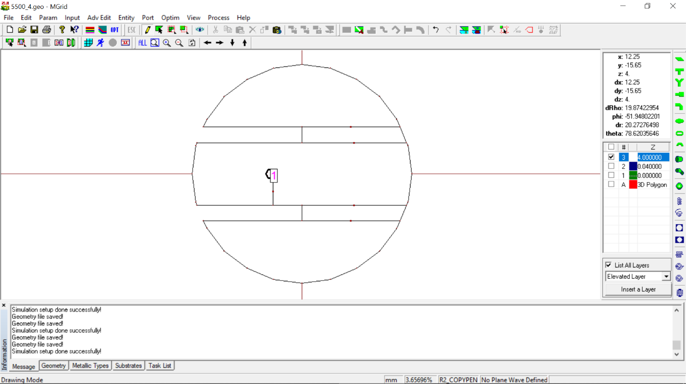

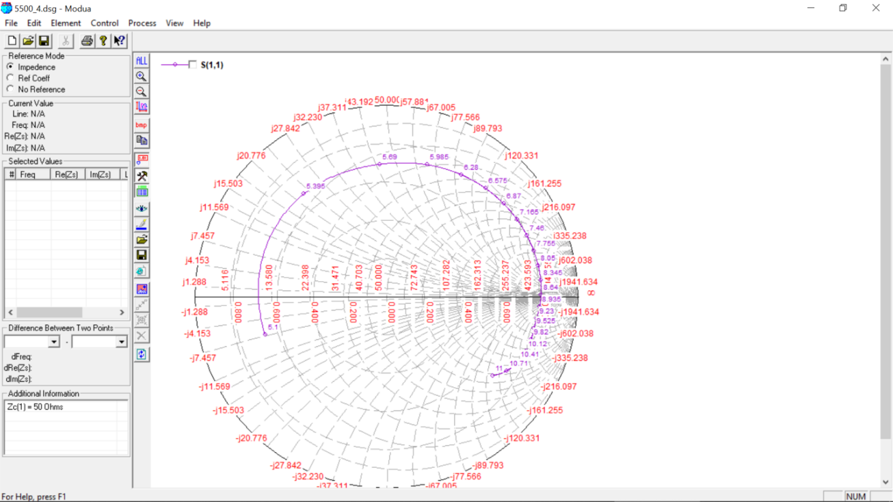

**5500 MHz, 4 mm (0.07 lambda) OPTIMIZED**

Original value: slot length **= 14 mm**

Optimized value: slot length **= 11 mm**

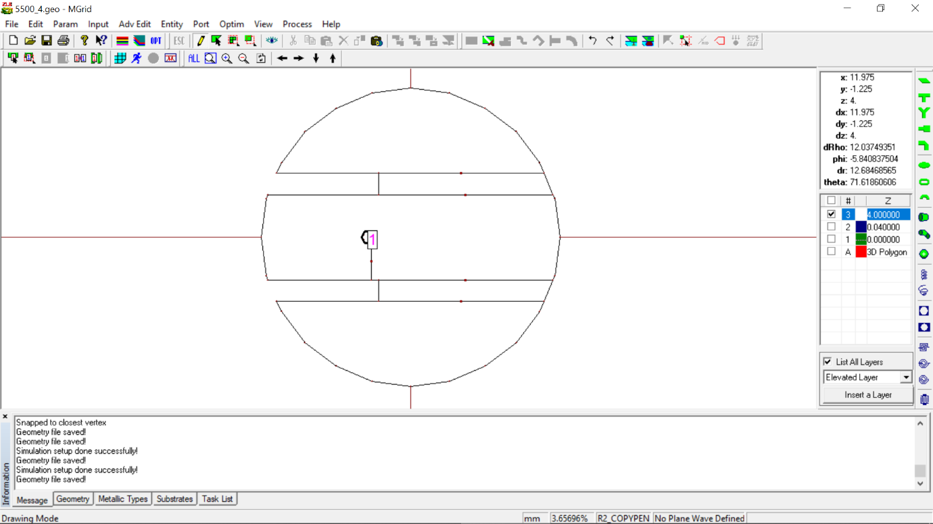

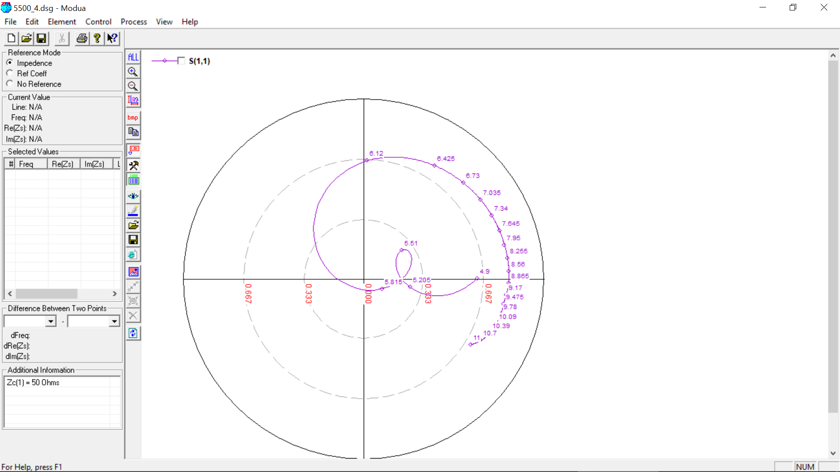

**600 MHz, 27 (0.05 lambda)**

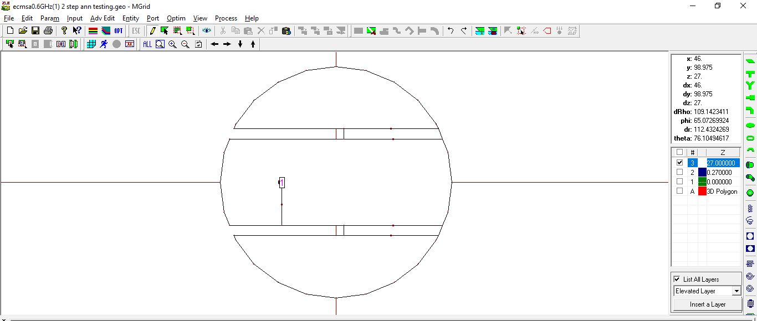

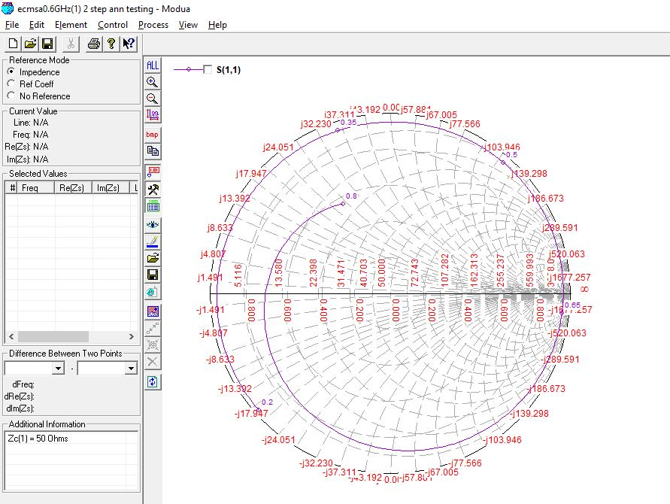

**600 MHz, 28 (0.07 lambda)**

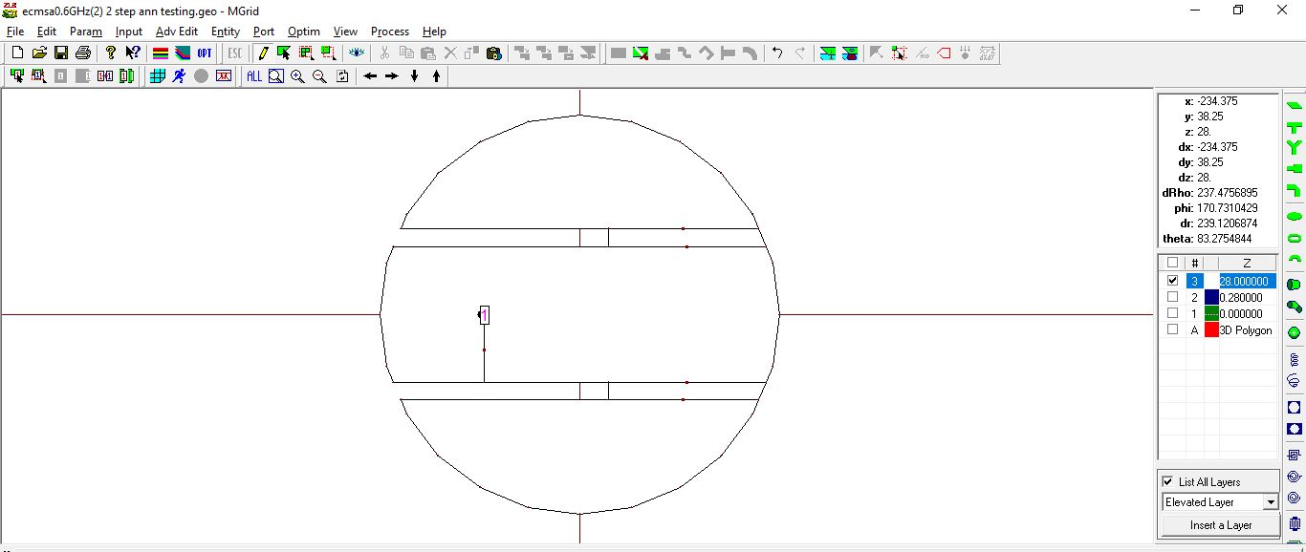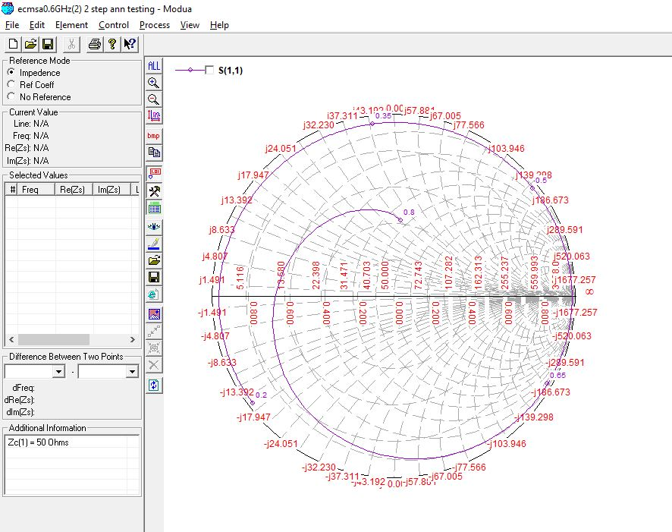

**700 MHz, 20 (0.05 lambda)**

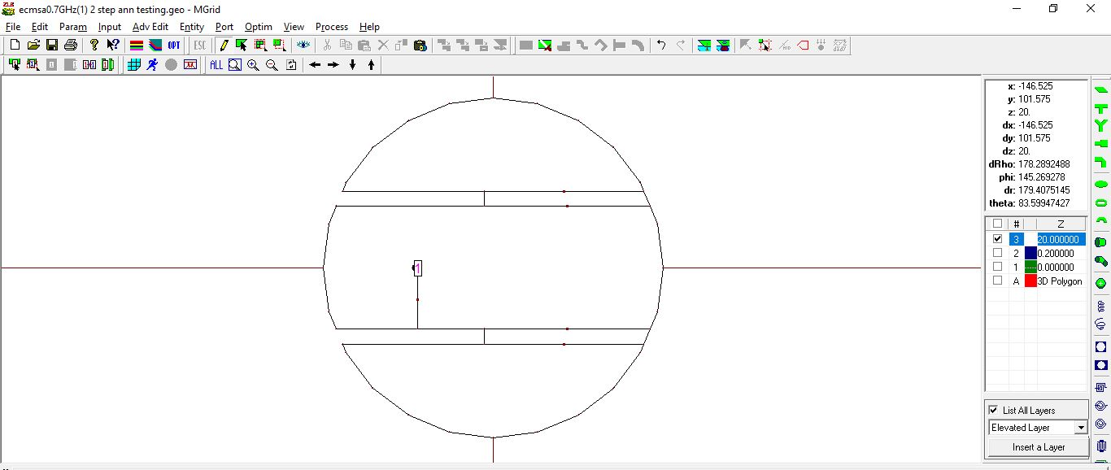

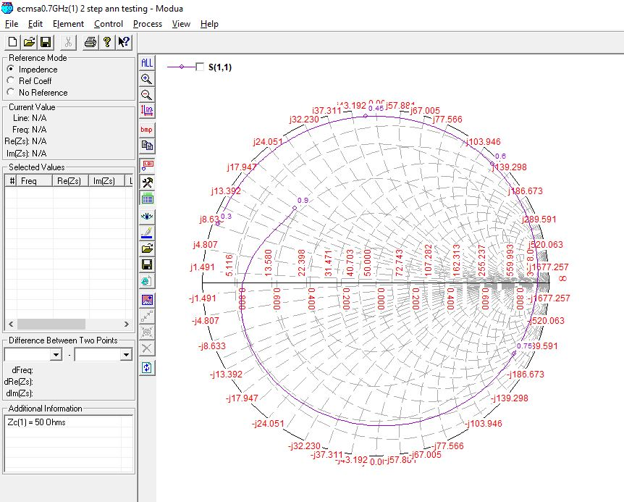

**700 MHz, 27 (0.07 lambda)**

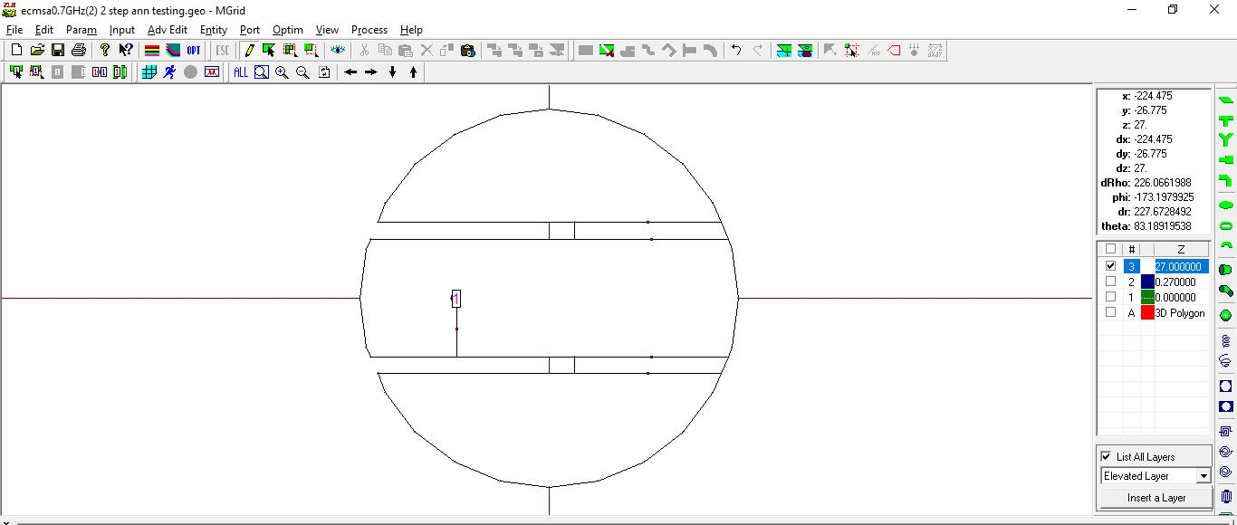

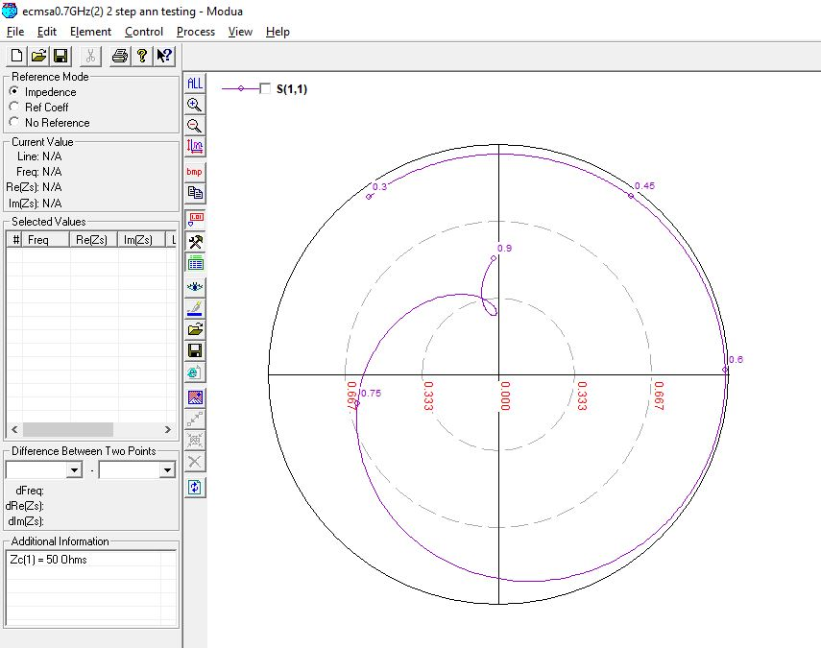

**700 MHz, 20 (0.07 lambda) OPTIMIZED**

Initial values: Feed Position**: -45mm,** Slot Length**: 102mm**

Optimized values: Feed Position**: -51mm,** Slot Length**: 105mm**

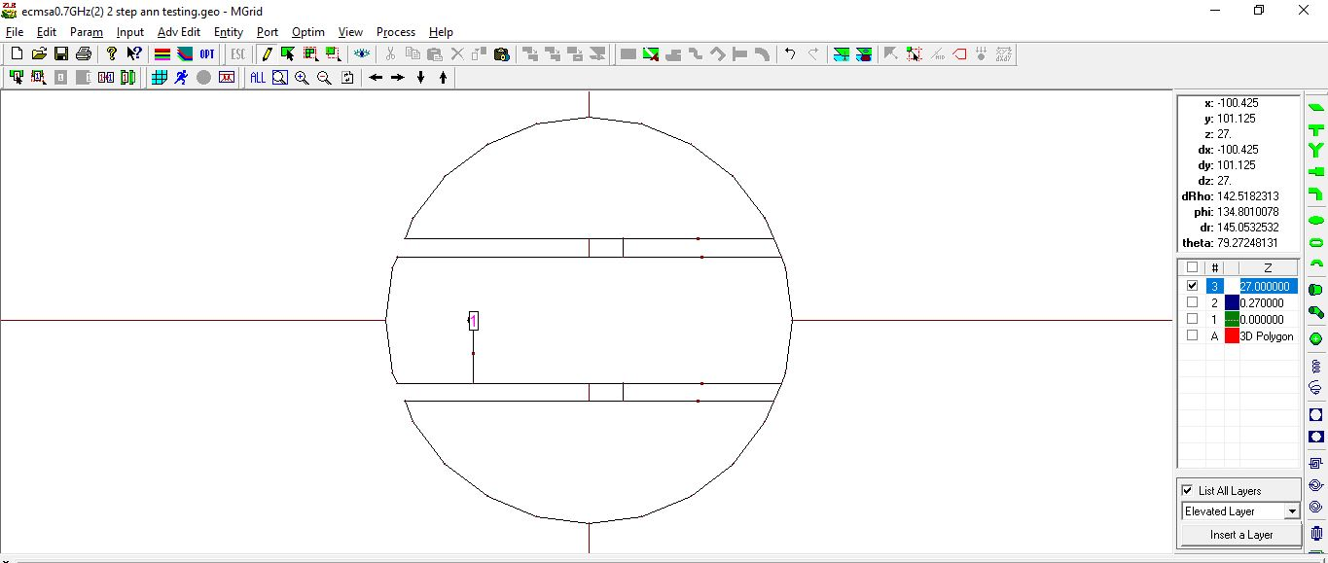

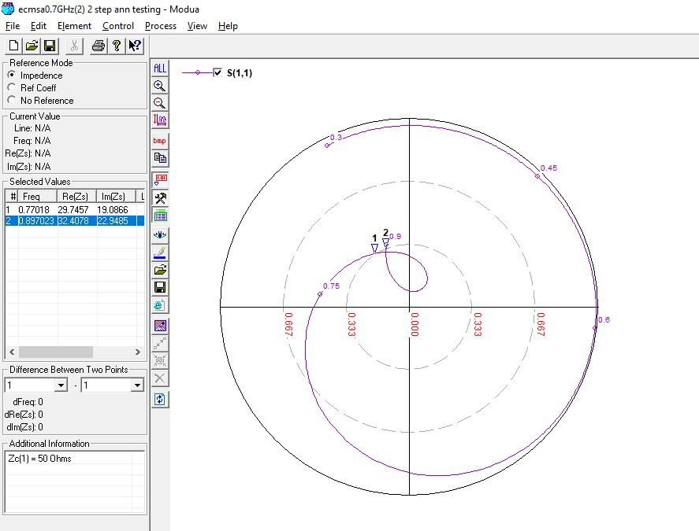

**BANDWIDTH COMPARISION BETWEEN 1-STEP AND 2-STEP ANN:**

|  |  |  |  |
| --- | --- | --- | --- |
| **Frequency (in MHz)** | **1 Step ANN (GHz)** | | **2 Step ANN (GHz)** |
| 600 (1) | OUTSIDE | | OUTSIDE |
| 600 (2) | OUTSIDE | | OUTSIDE |
| 700 (1) | OUTSIDE | | OUTSIDE |
| 700 (2) | 0.111 | | 0.0861 |
| 900 (1) | 0.0855 | | 0.1345 |
| 900 (2) | OUTSIDE | | OUTSIDE |
| 1500 (1) | 0.1937 | | 0.247 |
| 1500 (2) | 0.203 | | 0.1919 |
| 2100 (1) | 0.3175 | | 0.2898 |
| 2100 (2) | 0.2676 | | 0.2629 |
| 2700 (1) | 0.4413 | | 0.3943 |
| 2700 (2) | 0.4052 | | 0.3599 |
| 3300 (1) | 0.5068 | | 0.546 |
| 3300 (2) | 0.4269 | | 0.5038 |
| 3900(1) | 0.545 | | 0.648 |
| 3900(2) | 0.523 | | 0.476 |
| 4300(1) | 0.637 | | 0.706 |
| 4300(2) | 0.54 | | 0.628 |
| 4900(1) | 0.62 | | 0.732 |
| 4900(2) | 0.684 | | 0.728 |
| 5100(1) | 0.563 | | 0.836 |
| 5100(2) | OUTSIDE | | OUTSIDE |
| 5500(1) | 0.825 | | OUTSIDE |
| 5500(2) | OUTSIDE | | OUTSIDE |
|  | |